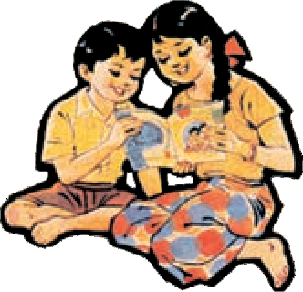

Education Department’s Sanction Number :

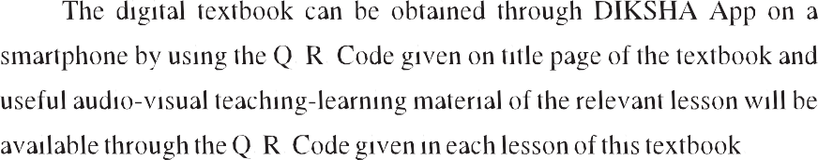

Pra-Shi-Sa / 2014 -15 / H / Language / Manjuri / D - 505 / 727 / Date 23.2.2015

**ENGLISH**

BALBHARATI

**STANDARD FIVE**

**Maharashtra State Bureau of Textbook Production and Curriculum Research, Pune.**



**Fourth Reprint : 2019**

**© Maharashtra State Bureau of Textbook Production and Curriculum Research, Pune - 411 004.**

The Maharashtra State Bureau of Textbook Production and Curriculum Research reserves all rights relating to the book. No part of this book should be reproduced without the written permission of the Director, Maharashtra State Bureau of Textbook Production and Curriculum Research, ‘Balbharati’, Senapati Bapat Marg, Pune 411004.

**English Language Committee :**

Dr Rohit Kawale Dr Aniket Jaware Dr I. P. Nadaf

Dr Shruti Chaudhary Shri. Nilesh Kedare

Smt. Dhanavanti Hardikar

**Cover and Illustrations:**

Reshma Barve

**Co-ordination :**

Dhanavanti Hardikar

Academic Secretary for Languages Santosh J. Pawar

Assistant Special Officer, English

**English Language Panel :**

Dr Lalita Vartak Dr Prabha Sampath

Smt. Samannaz B. Irani Smt. Smita Vijay Inamdar

Shri. Shridhar Madhukarrao Nagargoje Shri. Sultanchaand Hasan Shaikh

Dr Raju Govindrao Munghate Dr Prashant Kashinath Gawande Shri. Manohar Hilal Mali

Shri. Ashok Chintaman Raut Shri. Chandrakant Devrao Mohod Shri. Nitesh Kondiba Thite

Shri. Pankaj Vasantrao Patil Shri. Sharad Narayan Vasankar Shri. Harendra Nagesh Bidkar

Shri. Rajesh Prakashrao Khatavkar Shri. Gunawant Vitthalrao Barahate



**Production :** Sachchitanand Aphale, Chief Production Officer Sachin Mehta, Production Officer

Nitin Wani,

Asst. Production Officer

**Paper :**

70 GSM Creamwove

**Typesetting :**

DTP Section (Languages) Textbook Bureau, Pune.

**Printer :**

M/S. SAI OFFSET, KOLHAPUR

**Print Order No. :**

N/PB/2019-20/50,000

**Publisher :**

Vivek Uttam Gosavi **Controller**, Maharashtra State Textbook Bureau, Prabhadevi,

Mumbai - 400 025.



The Constitution of India

Preamble

WE, THE PEOPLE OF INDIA, hoving

solemnly resolved to constitute Indio into o SOVEREIGN SOCIALIST SECULAR

DEMOCRATIC REPUBLIC ond to secure to

o11 its citizens:

JUSTICE, sociol, economic ond politicol;

LIBERTY of thought, expression, belief, foith p

ond worship ;

EQUALITY of stotus ond of opportunity; ond to promote omong them ol1



i

FRATERNITY ossuring the dignity of the individuol ond the unity ond integrity of the Notion;

IN OUR CONSTITUENT ASSEMBLY this

* g twenty-sixth doy of November, 1949, do HEREBY

ADOPT, ENACT AND GIVE TO OURSELVES THIS CONSTITUTION.

1”



NATIONAL ANTHEM

Jana-gana-mana-adhinäyaka jaya hë Bhärata-bhägya-vidhätä,

Panjäba-Sindhu-Gujaräta-Maräthä Drävida-Utkala-Banga

Vindhya-Himächala-Yamunä-Gangä uchchala-jaladhi-taranga

Tava subha nämë jägë, tava subha äsisa mägë, gähë tava jaya-gäthä,

Jana-gana-mangala-däyaka jaya hë Bhärata-bhägya-vidhätä,

Jaya hë, Jaya hë, Jaya hë, Jaya jaya jaya, jaya hé.

PLEDGE

Indio is my country. All Indions ore my brothers ond sisters.

I love my country, ond I om proud of its rich ond voried heritoge. I sholl olwoys strive to be worthy of it.

I sholl give my porents, teochers ond oil elders respect, ond treot everyone with courtesy.

To my country ond my people, I pledge my devotion. In their well-being ond prosperity olone lies my hoppiness.

**Preface**

The **Right of Children to Free and Compulsory Education Act, 2009** and **National Curriculum Framework 2005** are two of the most important events that have influenced the field of primary education in the country. In the State of Maharashtra, too, primary education curriculum was revised to reflect their guidelines and expectations. We are happy to place this **English Balbharati** for Standard Five based on **‘Primary Education Curriculum 2012’** in your hands.

The RTE Act emphasizes all round development of the child, as also learning through activities, discovery and exploration in a child-friendly and child-centred manner; making the child free of fear, trauma and anxiety and helping the child to express views freely. We have tried to design our textbooks so that these principles become a part of the teaching- learning process.

Language plays a very important role at the primary level as other subjects, too, are learnt through language. A child learns language from all sources - in school, at home and from his/her environment. Teaching and learning of languages in school is designed to provide a series of graded activities in a suitable environment with a view to developing the child’s language skills and sensibilities to their full potential. The curriculum expects a balanced development of all the four skills of listening, speaking, reading and writing in the proper sequence. The emphasis in the initial years is on developing the child’s confidence and expression.

This textbook presents a number of activities in a particular sequence which will allow the child to learn language actively and in an enjoyable manner. Some important suggestions have been given for teachers and interested parents to help them motivate and guide the children while learning English. Teachers should handle the various items given in this book within the framework provided by the instructions.

The English Language Committee and the artist Reshma Barve have taken great pains to prepare this textbook. It was reviewed by teachers and experts and their comments and suggestions have helped us to give it a better shape. The Bureau is grateful to all of them.

We hope that the textbook will receive a warm welcome from students, parents and teachers.

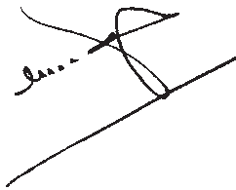

**Pune**

**Date :** 21 March 2015

Gudhi Padwa Chaitra 1, 1937

**(C. R. Borkar) Director** Maharashtra State

Bureau of Textbook Production and Curriculum Research, Pune.

### For Teachers and Parents

**This textbook will help the students to -**

 Enjoy reading stories and poems.

 Take active interest in gathering information and presenting it in an attractive manner.

 Learn to use a dictionary or other reference books.

 Enjoy writing imaginatively simple short descriptions, stories and poems.

 Write short reports, notes and essays.

 Share interesting stories, information, puzzles, jokes, etc. with friends and others.

 Learn to use polite language in speech and writing.

 Learn to prepare and present short speeches with the help of teachers/parents.

 The book contains stories, poems, informative passages, a play and a number of activities. All these items are important. None of them should be ‘dropped’.

 Taking into account the time available and the general ability of her students, the teacher should employ different methods and techniques for dealing with different items.

 Many of the exercises are open-ended. They do not have just one model answer. They have been included to allow the children to think creatively in the context of their experiences, feelings, ideas and world of imagination. The teacher should accept and encourage a variety of imaginative answers in response to them. The personal element in children’s responses should be valued.

**Create an atmosphere that facilitates language learning -**

 Have faith in your students’ abilities to think and to use language.

 Let the students speak and write a lot on their own.

 DO NOT focus on grammatical rules and students’ errors when they are trying to express themselves. You may feel that your students make too many mistakes. The best solution to this is to show them how to correct their own work using dictionaries, and by referring to similar constructions in the textbook. If necessary, have separate fortnightly or monthly sessions on ‘How to correct your own work’, but don’t let grammar and error correction get hold of all your teaching.

 The classroom arrangement should be such that students can easily form pairs or groups and you can easily move in the classroom to supervise their work.

 Put up a board where students can display their work regularly.

 Encourage students to circulate their writing in the classroom.

 The atmosphere in the classroom should be friendly, inspiring confidence in EVERY STUDENT. They should know that their teacher values their effort more than their mistakes.

 Multi-lingualism is a strength, not a weakness. Encourage students to compare and contrast English and other languages.

 PLEASE DO NOT PROVIDE READY-MADE OR ‘TEACHER-MADE’ MODEL

ANSWERS. They harm more than they help.

**English Balbharati-Standard Five - Learning Outcomes**

|  |  |
| --- | --- |
| **Suggested Pedagogical Processes** | **Learning Outcomes** |
| **The learner may be provided opportunities in pairs/groups/ individually and encouraged to–**   * discuss and present orally, and then write answers to text-based questions, short descriptive paragraphs * participate in activities which involve English language use, such as role play, enactment, dialogue and dramatisation of stories read and heard * look at print-rich environment such as newspapers, signs and directions in public places, pamphlets, and suggested websites for language learning * prepare speech for morning assembly, group discussions, debates on selected topics, etc. * infer the meaning of unfamiliar words from the context while reading a variety of texts * refer to the dictionary for spelling, meaning and to find out synonyms and antonyms * understand the use of synonyms, such as ‘big/large’, ‘shut/ close’, and antonyms like inside/outside, light/dark from clues in context * relate ideas, proverbs, sayings and expressions in the stories that they have heard, to those in their mother tongue/ surroundings/cultural context * read independently and silently in English, adventure stories, travelogues, folk/fairy tales, etc. * find out different forms of writing (informal letters, lists, stories, leave application, notice etc.) * learn grammar in a functional, contextual and integrated manner (such as use of nouns, adverbs; differentiates between simple past and simple present verbs) * use linkers to indicate connections between words and sentences such as ‘Then’, ‘After that’, etc. * take dictation of sort texts such as lists, paragraphs and dialogues * enrich vocabulary through crossword puzzles, word chain, etc. * look at cartoons/ pictures/comic strips with or without words and speak/write a few sentences about them * write a ‘mini biography’ and ‘mini autobiography’ | **The learner :**   * + 1. Recites and sings English songs and poems with actions.     2. Acts according to instructions and commands given in English.     3. Listens to others and responds accordingly.     4. Answers simple questions based on poem, story, spoken passages, conversations, etc.     5. Acts as per the announcements in a classroom or in the school environment.     6. Understands the details of a story / passage.     7. Participates in skits, plays, monologues with interest.     8. Describes things, pictures, events, festivals with simple and short sentences.     9. Comperes various programmes with some preparation.     10. Delivers different speeches eloquently.     11. Reads independently in English storybooks, news items / headlines, advertisements, talks about it and composes short paragraphs.     12. Reads and understands charts, tables, time tables, flow charts, maps, etc.     13. Reads words, phrases, sentences, dialogues, passages with understanding.     14. Finds out meanings of new words from a dictionary and looks up the spellings of words in a dictionary.     15. Reads announcements in a clear and audible voice with proper pronunciation.     16. Takes dictation for different purposes such as lists, paragraphs, dialogues.     17. Writes paragraphs in English using punctuation marks appropriately.     18. Writes short descriptions of incidents, pictures, etc.     19. Attempts to write a continuous and meaningful passage and short story creatively.     20. Writes a description of a given process in a step by step manner.     21. Writes various types of formal / informal letters.     22. Writes a short autobiography of a thing, object and person of their choice.     23. Appreciates either verbally / in writing the variety of food, dress, customs and festivals as read / heard in his / her day-to-day life, in storybooks / heard in narratives. |

**CONTENTS**

|  |  |  |  |
| --- | --- | --- | --- |
| **Unit One** | **Page** | **Unit Three** | **Page** |
| **1. What a Bird Thought** | 1 | **17. On the Water** | 42, 43 |
| **2.** Daydreams | 2 - 4 | **18.** Weeds in the Garden | 44 - 46 |
| **3.** Be a Good Listener | 5, 6 | **19.** Be a Good Host and Guest | 47 - 50 |
| **4. Strawberries** | 7 | **20. Only One Mother** | 51 |
| **5.** The Twelve Months | 8 -13 | **21.** The Journey to the Great Oz | 52 - 56 |
| **6.** Announcements | 14, 15 | **22.** A Book Review | 57, 58 |
| **7.** Major Dhyan Chand | 16 -18 | **23.** Write your own Poem | 59 |
| **8.** Peer Profile | 19, 20 | **24.** Senses Alert | 60, 61 |
| **Unit Two** | **Page** | **Unit Four** | **Page** |
| **9. The Triantiwontigongolope** | 21, 22 | **25. The Man in the Moon** | 62 |
| **10.** Three Sacks of Rice | 23 - 25 | **26.** Water in the Well | 63, 64 |
| **11.** Be a Good Speaker | 26, 27 | **27.** The Legend of Marathon | 65 - 67 |
| **12. Count your Garden** | 28 | **28.** All about Money | 68 -70 |
| **13.** The Adventures of Gulliver | 29 - 32 | **29. A Lark** | 71 |
| **14.** A Lesson for All | 33 - 37 | **30.** Be a Netizen | 72 -74 |
| **15. Bird Bath** | 38 | **31.** Give your Mind a Workout ! | 75, 76 |
| **16.** Write your own Story | 39 - 41 | **32.** Helen Keller | 77 - 79 |
|  |  | **33.** Rangoli | 80 - 82 |
|  |  | Language Study | 83 - 88 |

**Unit One**



**1. What a Bird Thought**

I lived first in a little house, And lived there very well ;

The world to me was small and round And made of pale-blue shell.

I lived next in a little nest, Nor needed any other ;

I thought the world was made of straw, And covered by my mother.

One day I fluttered from the nest, To see what I could find.

I said, “The world is made of leaves ; I have been very blind.”

At last I flew beyond the tree, And saw the sky so blue ;

Now, how the world is really made I cannot tell - can you ?

**Things to do :**

1. **Find and list the rhyming words from the poem.**
2. **Learn and recite the poem.**
3. **Describe the following in one or two lines.**
   * The first little house of the bird. * The nest. * The world around the bird’s nest.
4. **Imagine the following and write about each in your own words :**
   * What the world looks like to a baby. * What the world looks like to a fish.

## 2. Daydreams

Once there lived a couple who spent a lot of time in idle talk. One day, the husband said, “I have

always wanted to keep cows. If, by chance, I get some extra money from somewhere, I am going to buy a few cows.”

“But that means a lot of work. You have to feed the cows, walk them, bathe them, milk them - cows need a lot of looking after. One cow would be enough. There’s no need to buy more cows,” said the wife.

“But think of all the milk we’ll get if we buy more,” said the husband.

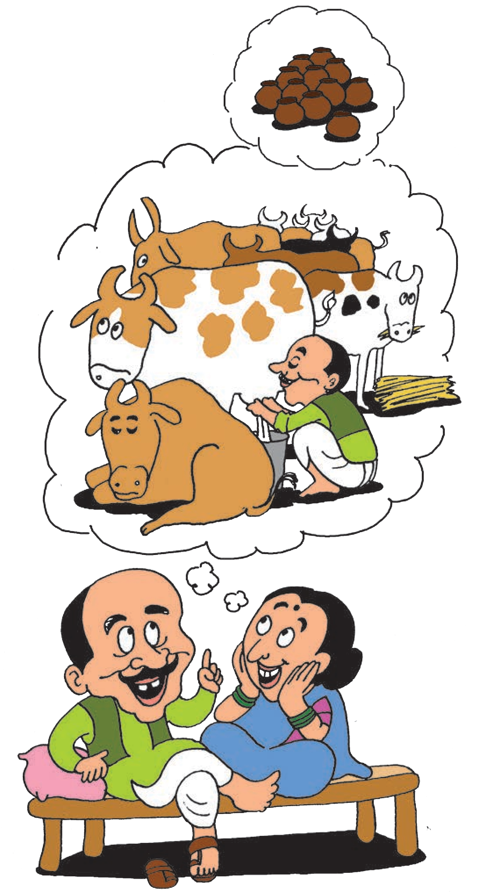“That’s true.” The wife agreed. “There will be so much milk that we can even have plenty of dahi and butter and ghee. Wouldn’t it be lovely ! How lucky that I have all these earthen pots kept aside. I’ll use one of the pots for milk, one for dahi, one for butter. The ghee, I’ll put in another jar. And I’ll use this remaining pot to send milk to my sister.”

“Send milk to your sister ! Who said you could send milk to your sister !”

“There will be plenty of milk, if we have so many cows. Why shouldn’t I send it to my sister ?”

“Because we are going to sell it in the market - that’s why. I will decide what to do with all that milk. And not a drop of it goes to your sister, remember !”

“I’ll see how you can stop me from sending a pot full of milk to my dear sister. I do all the hard work running after the cows so naturally I will decide what happens to the milk. Just try stopping me !” the wife exclaimed.

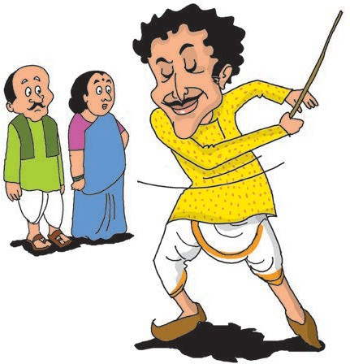

“Is that so !” shouted the husband. “Watch this, then !” He began to lift and smash the earthen pots one by one. His wife began to scream.

Gopal Bhand, who was passing by, heard all the commotion and

rushed inside. When he heard what had happened, he picked up a stout stick that stood in a corner and began to swish it through the air and pound it on the floor. The husband and wife were both astounded to see his antics.

“What are you doing ?” they enquired.

“Move aside,” said Gopal Bhand. “I have to drive away your greedy cows. You have let them wander and now they have ruined my field of beans and cucumbers ! Oh, my lovely field of beans and cucumbers !”

“But you don’t have a field of beans and cucumbers !” said the husband. As soon as he said that, Gopal Bhand stopped wielding the stick and looked at him with raised eyebrows. The husband and wife understood what he was trying to tell them. Can you tell what he wanted to say ?

**Things to do :**

1. **Read the following words aloud and copy them in your notebook.**

* idle * enough * exclaimed * commotion

* astounded * antics * wander * wielding

1. **Answer the following questions.**
   1. What did the husband want to buy ?
   2. What plans did the wife make ?
   3. What did the husband want to do with the extra milk ?
   4. What did Gopal Bhand say he was doing ?
   5. Did Gopal Bhand have a field ?
   6. What did Gopal Bhand want to tell the husband and wife ?
   7. What is the difference between a ‘dream’ and a ‘daydream’ ?
2. **Activities**
   1. Form groups of three and read the conversation in the story aloud.
   2. Write about your own daydream in short.
   3. Begin with a word and write as many other related words or ideas that occur to you in the form of a concept chart or concept map. You can choose a word from those given here or you may choose any other suitable word.

* school * home * food * medicine

fun

recess

clock

maths

bell

teacher

school

time-table

new

pencil box

notebooks

bag

friends

games

examples

problem sets

1. **Group Work**

railway

train

journey

play

Discuss in groups of 5, the occasions on which you can use each of the following expressions. List at least 3 occasions each.

* That’s true ! * Wouldn’t it be lovely ! * Just try stopping me !

1. **Language Study (See pages 84-88.)**
   1. A phrase is a meaningful group of words, for example, ‘one day’, ‘some extra money’, ‘a few cows’, ‘all the milk’.

From the story, find at least three phrases each that begin with or include each of

the -

articles

* + - a * an * the.
  1. Choose ‘a’ or ‘an’ correctly and fill in the blanks.

*  earthen pot *  cow *  jar *  sister

* + -  stout stick *  lovely field *  eyebrow
  1. Write the plural forms of the following.

* cow * pot * jar * sister * market

* drop * stick * corner * field * cucumber

## 3. Be a Good Listener



It is important to be a ‘good listener’ when you are learning a language, or when you are dealing with other people. Are you a ‘good listener’ ? You can find it out with the help of the following questions.

**One.** When you are listening to someone, do you look at the person or do you turn your head away or toy with something else ?

Good listeners look at the speaker.

**Two.** Do you pay attention to what the speaker is saying ?

Good listeners pay close attention to the speaker.

**Three.** Do you make any special efforts to understand the speaker ?

Here are some of the things that will help you understand the speaker better :

* If you hear some new or unfamiliar words try to guess their meaning from the context.
* You can try to guess what the speaker will say next.
* Try to keep listening even when you feel that you do not understand the speaker, or even when you disagree with the speaker. Wait for the speaker to finish what he is saying. Then you can get your doubts clarified by asking polite questions.
* Do not feel shy or afraid to ask questions if you do not understand what is being said. Put your questions to the speaker politely.
* Sometimes, it helps to note down important words or points even as you listen.
* Lastly, it also helps to keep thinking about what you heard. You may grasp the meaning of a difficult word or phrase later on.

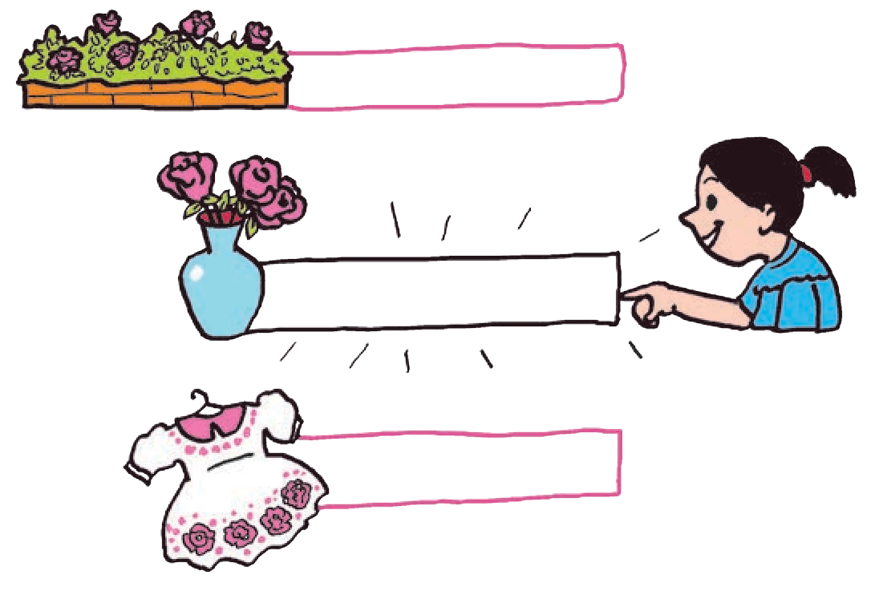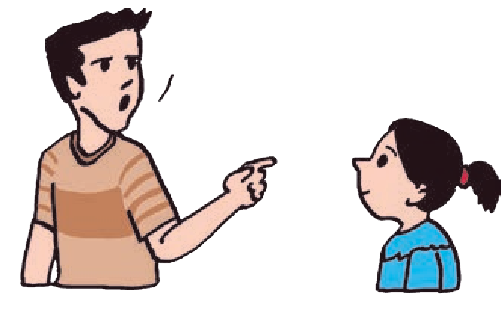

**Please bring me the vase that has pink roses. It’s on the dinning table.**

**‘Vase’ means :**

**a bed of roses**

**a kind of pot**

**a frock**

**Things to do :**

1. **Write the characteristics of a good listener.**
2. **Listen carefully and guess how the sentence would end.**
   1. Once there was a crow. He was very thirsty. He wanted to drink .
   2. There were dark clouds in the sky. Soon, it began to .
   3. This step is broken. Please be .
   4. When the students saw the question paper, they were .
   5. When the teacher read the answer papers, she was .
3. **Listen carefully and write all the words correctly.**
   1. You are right. Write it down in the right hand corner.
   2. ‘I need two books.’ ‘Me, too.’ ‘I gave one to my sister.’
   3. He ate the whole apple but there were holes in the apple.
   4. Do you know the tale of the mouse who had seven tails ? Please tell it to us.
   5. I knew you wanted new shoes.
4. **Activities**
   1. Sit quietly for some time. Close your eyes and listen carefully to all the sounds that you hear. Can you guess what sounds they are, who or what is making that sound ?

Note down what you heard.

* 1. List 5 of the sounds that you like and 5 of the sounds that you don’t like.

1. **Group Work**

Form groups. Discuss how one can be a ‘good reader’. Use the points in the above passage in your discussion. Write down the points that show what makes a ‘good reader’.

Good readers try to guess the meaning of new or unfamiliar words from the context.

6 Unit 1

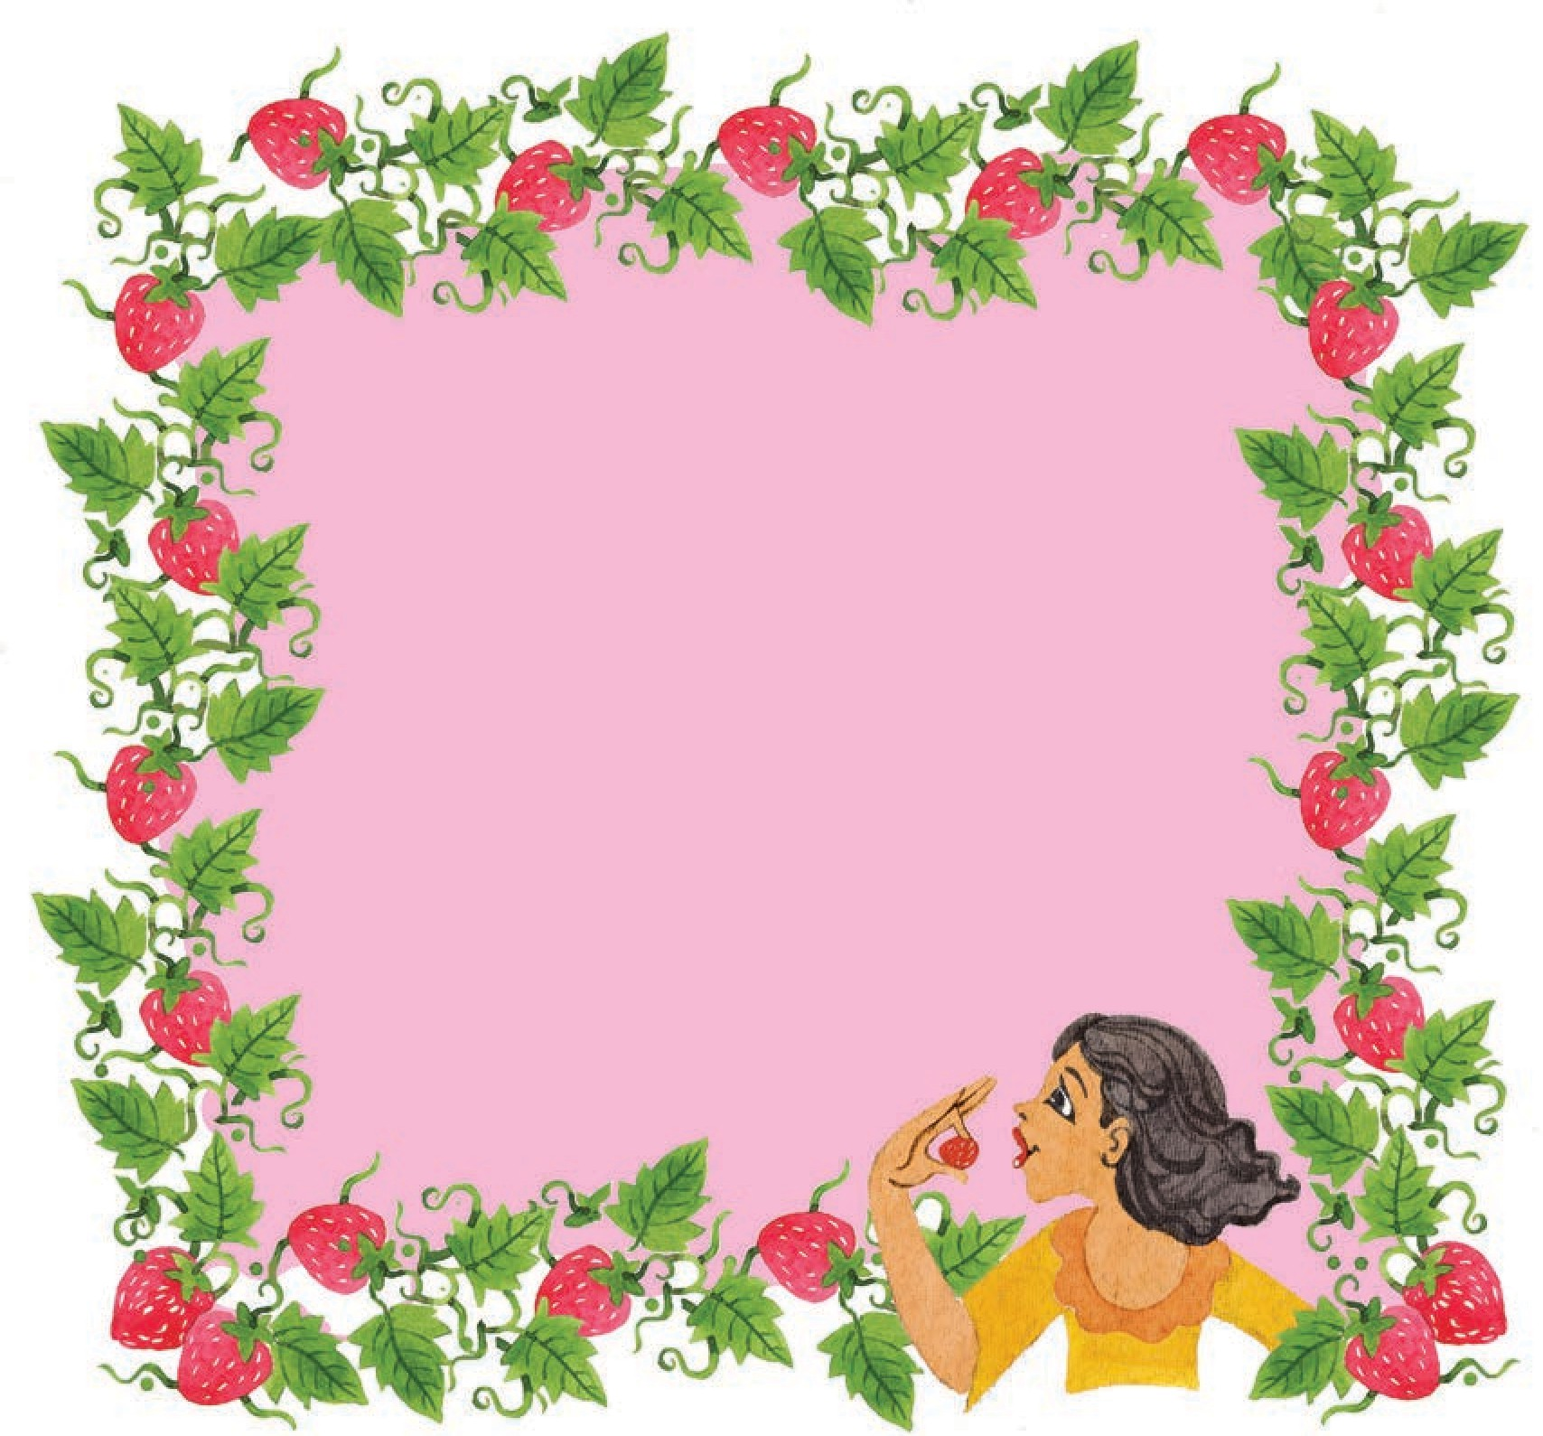

**4. Strawberries**

Strawberries that in gardens grow Are plump and juicy fine,

But sweeter far as wise men know Spring from the woodland vine.

No need for bowl or silver spoon, Sugar or spice or cream,

Has the wild berry plucked in June Beside the trickling stream.

**Things to do :**

1. **Learn and recite the poem.**
2. **Read the poem and answer the following.**
   1. Which are the two different places where strawberries grow ?
   2. What are the two different ways of eating strawberries ?
   3. Which strawberries are plump and juicy ?
   4. Which strawberries are sweeter ?
   5. How would you like to eat your strawberries ?
3. **Activities**
   1. Find out when and where we get strawberries in Maharashtra.
   2. Make a list of your favourite fruits and vegetables and note down the time of the year when they are available in plenty.
   3. Have you ever eaten any fruit / vegetable picking it straight from the tree or field ? Write about that experience in 3-5 lines.

## The Twelve Months



ONCE upon a time, in a faraway country, there lived a mother who had two daughters. One was her own child, the other was her stepdaughter. She was very fond of her own daughter, but she hated her stepdaughter. The only reason was that Marouckla, the stepdaughter, was prettier than her own daughter, Holena.

The gentle-hearted Marouckla did not know how beautiful she was, and so she could never make out why her mother was always so cross with her.

Marouckla had to do all the housework, tidying up the cottage, cooking, washing, spinning, weaving and sewing. She liked work and she did it all without a word of complaint while Holena spent the time adorning herself and lazing about. Even then, Holena and her mother scolded and rated and abused Marouckla every day. They envied her so much that one day, they decided to throw her out in the freezing cold to get rid of her.

“Go, Marouckla, and get me some violets from the forest; I want to wear them and to smell them,” said Holena.

“But, my dear sister, it is impossible to find violets in the snow,” said poor Marouckla.

“How dare you argue when I tell you to do something ? Off you go at once, and if you don’t bring me violets from the forest I’ll kill you !” said Holena threateningly.

The stepmother caught hold of Marouckla,

turned her out of the door, and slammed it to after her.

Marouckla went into the forest weeping bitterly. The snow lay deep, and there wasn’t a human footprint to be seen. Marouckla wandered about for a long time, tortured by hunger and trembling with cold.

At last, she saw a light in the distance. She went towards the glow, which came from the top of a mountain. A big fire was burning there, and round the fire were twelve stones with twelve men sitting on them. Three of them had snow-white beards, three were not so old, and three were still younger. The three youngest were the handsomest of them all. They were not speaking, but all sitting silent. These twelve men were the twelve months. Great January sat highest of all; his hair and beard were as white as snow, and in his hand he held a club.

Marouckla was frightened. She stood still for a time in terror, but, growing bolder, she went up to them and said, “Please, kind sirs, let me warm my hands at your fire.”

Great January nodded, and asked her, “Why have you come here, my dear little girl ? What are you looking for ?”

“I am looking for violets,” answered Marouckla.

“This is no time to be looking for violets, for everything is covered with

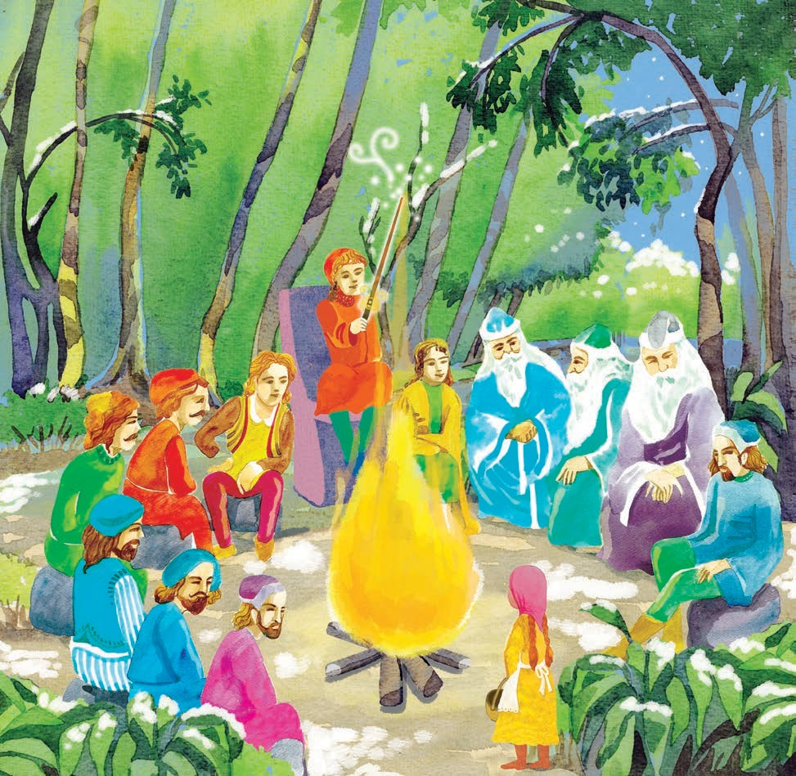

snow,” answered Great January.

“Yes, I know; but my sister Holena and my stepmother said that I must bring them some violets from the forest. If I don’t bring them, they’ll kill me. Tell me, fathers, please tell me where I can find them.”

Great January stood up and went to one of the younger months - it was March - and, giving him the club, he said, “Brother, take the high seat.”

March took the high seat upon the stone and waved the club over the fire. The fire blazed up, the snow began to melt, the trees began to bud, and the ground was at once covered with grass. It was springtime.

The violets began to bloom among their little leaves, and before Marouckla had time to think, so many of them had sprung up that they looked like a blue cloth spread out on the ground.

“Now, pick them quickly, Marouckla !”

commanded March.

Marouckla picked them joyfully till she had a big bunch. Then she thanked the

months with all her heart and scampered merrily home.

Holena and the stepmother wondered when they saw Marouckla bringing the violets. They opened the door to her, and the scent of violets filled all the cottage.

“Where did you get them ?” asked Holena sulkily.

“They are growing under the bushes in a forest on the high mountains.”

Holena snatched all the flowers and did not give even a single one to her sister.

The next day, she called to her sister and said, “Go, Marouckla, and get me some strawberries from the forest.”

“Alas! dear sister, where could I find any strawberries in this hard winter ?” said Marouckla.

“How dare you argue ! Go at once and get me the strawberries, or I’ll kill you !”

The stepmother caught hold of Marouckla and pushed her out of the door and shut it after her.

Marouckla went to the forest weeping bitterly. The snow was lying deep, and there wasn’t a human

footprint to be seen anywhere. She wandered about for a long time, tortured by hunger and trembling with cold. At last, she saw the light she had seen the other day. Overjoyed, she went towards it. She came to the great fire with the twelve months sitting round it.

“Please, kind sirs, let me warm my hands at the fire.”

Great January nodded, and asked her, “Why have you come again, and what are you looking for here ?”

“I am looking for strawberries. My sister Holena and my stepmother bade me bring some strawberries, and if I don’t, they will kill me. Tell me, fathers, tell me, please, where I can find them.”

Great January arose. He went over to the month sitting opposite to him - it was June - and handed the club to him, saying, “Brother, take the high seat.”

June took the high seat upon the stone and swung the club over the fire. The fire shot up, and its heat melted the snow in a moment. The ground was all green, the trees were covered with leaves, the birds began to sing, and the forest was filled with all kinds of flowers. It was summer. The ground under the bushes was covered with white starlets, the starry blossoms were turning into strawberries every minute. They ripened at once, and before Marouckla had time to think, there were so many of them that it looked as though a red carpet had been spread on the ground.

“Pick them at once, Marouckla !” commanded June.

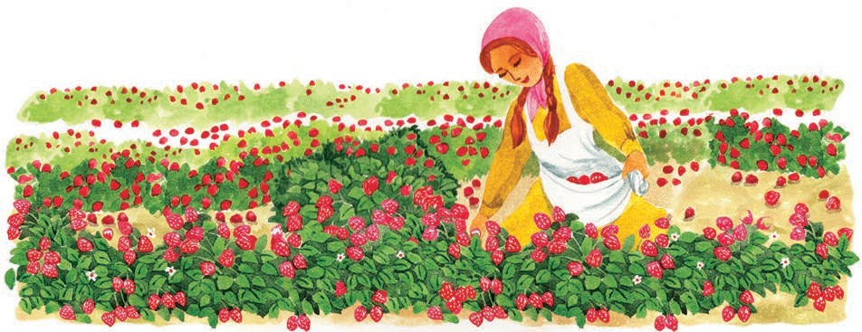

Marouckla picked them joyfully till she had filled her apron full. Then she thanked the months with all her heart and scampered merrily home.

Holena and the stepmother wondered when they saw Marouckla bringing the strawberries. Her apron was full of them.

“Where did you pick them ?” asked Holena sulkily.

“There are plenty of them growing in the forest on the high mountains.”

Holena took all the strawberries, and ate them all up with her mother. They didn’t leave even a single one for Marouckla.

On the third day, Holena ordered, “Marouckla, go into the forest and get me some red apples.”

The stepmother caught hold of Marouckla and without giving her a chance to speak, pushed her out of the door and shut it after her.

Marouckla went to the forest again, weeping bitterly. But she didn’t wander about this time. She ran straight to the

top of the mountain where the big fire was burning and the twelve months were sitting round the fire.

“Please, kind sirs, help me.”

Great January nodded, and asked her, “What are you looking for today ?”

“I am looking for red apples. If I don’t bring them, my sister and my mother will kill me. Tell me, father, tell me, please, where I could find them.”

Great January rose up. He went over to one of the older months - it was September. He handed the club to him and said, “Brother, take the high seat.”

Month September took the high seat upon the stone and swung the club over the fire. The fire began to burn with a red flame, the snow began to melt. But there was a cold wind that sent the faded leaves down to the ground. It was autumn. Marouckla saw just one apple-tree with red apples hanging high among its branches.

“Shake the tree at once, Marouckla !” commanded September.

Right gladly Marouckla shook the

tree, and first one apple fell down and then another.

“Now, Marouckla, that’s enough. Run home quickly !” shouted the months.

Marouckla obeyed at once. She picked up the apples, thanked the months with all her heart, and ran merrily home.

Holena and the stepmother wondered when they saw Marouckla bringing the two apples.

“Where did you get them ?” asked Holena.

“I found them in the forest on the high mountain.”

“And why didn’t you bring more ? Or did you eat them on the way home ?” said Holena harshly.

“Alas ! sister dear, I haven’t even tasted them. I shook the tree twice; two apples fell down, and they wouldn’t let me shake the tree again. They shouted to me to go straight home,” protested Marouckla.

“May you be struck to death by lightning !” said the wicked Holena and began to eat the apple. It tasted so delicious that she told her mother she had never tasted anything so nice in all her life. The stepmother liked it too. When they had finished, they wanted some more.

“Mother, give me my fur coat. Let’s go to the forest ourselves and get the apples. That ragged little wretch

would eat them all up again on her way home. We’ll find the place all right, and I’ll shake them all down, however they shout at me.”

Her mother agreed readily. They wrapped themselves in fur coats and shawls and off they went to the forest.

The snow lay deep, and they wandered about for a long time, but at last they saw the top of the mountain where the big fire was burning and the twelve months were sitting. They stepped up to the fire and stretched out their hands to warm them, without asking permission or speaking one polite word.

“Why have you come here, and what are you looking for ?” asked Great January crossly.

“Why do you want to know, you old fool ?” replied Holena angrily. “It’s no business of yours,” said her mother.

Great January frowned and swung the club over his head. The sky grew dark in a moment, the fire burned low, the snow began to fall thick and an icy wind began to blow through the forest. Holena and her mother couldn’t see one step in front of them.

They tried to find their way out but the snow fell in huge masses, and soon, they were lost in it.

At home, Marouckla waited and waited and yet Holena and her mother did not come back. When she went

to search for them she found neither her mother and sister nor the twelve months in the forest. At last, she returned home sadly.

So, good Marouckla inherited the cottage and the land around it. She married a kind husband and they both lived happily ever after.

*-Traditional*

**Things to do :**

1. **Find the meaning of the following words.**

* adorning * rated * abused * starlets * delicious

1. **Read the words. Write the words that combine to make each of them.**
   * stepmother * footprint * snowwhite
   * springtime * gentle-hearted * anywhere

**Now write other meaningful words that begin/end with -**

* + the first word in each * the second word in each.

1. **Answer the following questions.**
2. Why did Marouckla’s stepmother hate her ?
3. In what season does the story take place ?
4. Does Marouckla get any of the things she brings ?
5. Why do Holena and her mother go out in the snow themselves ?
6. Why is Great January annoyed with Holena and her mother ? Does he help them ?
7. **Describe the following with the help of the story.**
   * Springtime * Summer * Winter
8. **Group Work**
9. Form groups of 3. Read aloud the conversations in the story, each group presenting one piece of conversation.
10. Form groups of 5. Find at least two fairy tales / folk tales each and share them with other members in your group. Make a collection of 10 different stories in each group.
11. **Language Study (See pages 84-88.)**

Note the words that are highlighted.

fire

top

mountain

ran to the

Marouckla

of the

where the big

was burning.

The highlighted words are all

nouns

1. **Activity**

. Find 5 other nouns from the story.

Hold a story-telling competition in which each one narrates a folk-tale or fairy-tale.

* * *

## Announcements



The school has organized a Story-telling Competition for

Classes V, VI and VII from 21st to 25th of July. The competition

will be held in the school hall at 10 in the morning. Children may

select

Three prizes will be given for each category.

The time limit is 3-5 minutes. Those who wish to participate

may

contact Mrs Sanjana Mohite for other details. They must

register their names with her before the 16

of July.

Tomorrow, that is, on the 10th of July, school will close an hour earlier, as the teachers have to attend an important

P. T. A. meeting. So please inform your parents to arrange to pick you up at 2 pm instead of 3 pm.

1. A fable

2. A folk-tale

3. A fairy-tale

4. A True Story

5. A Funny Story

**Things to do :**

1. **Choose a suitable heading for each announcement from those given below.**



Construction work to extend the school building will start next week. All students are cautioned not to cross over the fence at the construction site. It is dangerous and may cause you injury.

Please stay away from that fence.

* + Change in School Hours * Cleanliness
  + Story-telling Competition * Lost and Found
  + Warning * Football Match

1. **Present any one of these announcements yourself, orally.**
2. **Group Work**
3. An announcement can be made in every class, orally. Or, it can be put up on the school notice-board. Discuss and decide what method should be used for each of the announcements given here.

* Oral announcement * Written notice * Both

1. Make groups. One person in the group chooses an announcement. Everyone in the group reads that announcement silently but carefully, and closes their books. Then that person presents the announcement, changing one of the details in the announcement. Others spot the change. For example, you might say ‘red’ key chain instead of ‘blue’ in the last announcement.
2. Name the occasion or reason for which each of the announcements is being made. Then think of an occasion and prepare an announcement for it as a group activity.
3. **Activity**

Prepare an announcement for an occasion like the ones mentioned here.

## Major Dhyan Chand



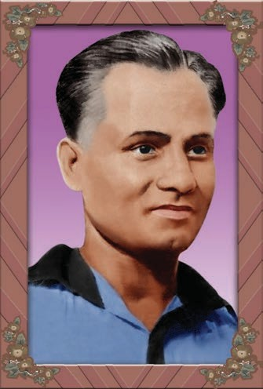Saturday, 15 August 1936. It was the day of the Hockey finals during the Olympic events held in Berlin, Germany. Germany had defeated several teams to enter the finals against the Indian team. They were the hosts of the Olympics, and they were sure of their victory. Perhaps that was the reason why their ruler Hitler had himself come to watch the match.

All the day before, it had rained heavily. The entire field had become water-logged. But 15th August being the last day of the Games, it was not possible to postpone the match any further. The Indian team was a little under pressure as they had lost to Germany in the practice match and they were not very comfortable with the wet ground.

About forty thousand people had gathered in the hockey stadium to cheer

Germany against India. The Maharaja of Baroda State, the Prince of Bhopal and a few other Indians had also come to support the Indian Team.

The match started exactly at 11 am. The German team had adopted a novel strategy of using the Indian technique of short distance passes against the Indian team itself. They had resorted to a very aggressive play. The Indian team was offering an equally strong resistance. No team could make a goal during the first half hour. During the 32nd minute, Roop Singh scored the first goal, hitting the ball towards the goalpost from a difficult angle.

In the second half of the match, the Indian team found a firm footing. The entire team played as one and made three more goals against Germany. Two of them were made by the Captain of the Indian team, Dhyan Chand. However, the German players were also trying their level best to win. They, too, succeeded in making one goal.

Now, only a few last minutes were left. Dhyan Chand had resolved to win

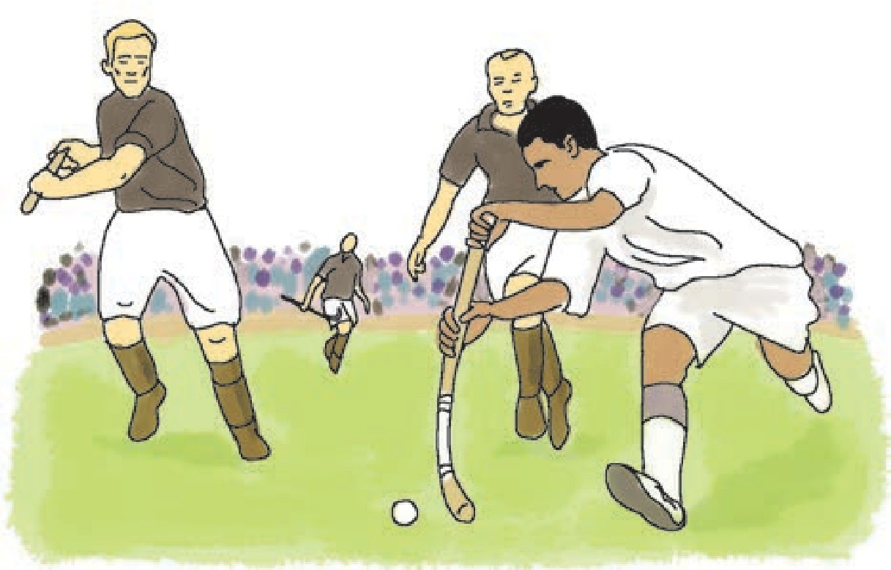

16 Unit 1

the match at any cost without allowing Germany to make any more goals. His spiked shoes were making it difficult for him to run fast on the wet ground. He removed the shoes and the socks and began to run barefoot. Using his amazing skill of dribbling and his near- magical game, he began to send one pass after another to the players in the ‘D’, that is, in the defenders’ or opponents’ area from where they could make goals. They, too, did not let the passes go waste. The Indian team scored three more goals. Dhyan Chand could have easily made the goals himself from his own position, but he never played a selfish game. Skilfully, he took the ball away from the German defenders and made it possible for the players in the D to score goals.

The German strategy had proved fruitless. A defeat stared them in the face. Some of the frustrated German players then resorted to a rough game. The German goalkeeper pounced on Dhyan Chand and hurt him. But Dhyan Chand was a true soldier. After a little first-aid, he immediately returned to the field and held the spectators spellbound with his game. At last, he scored the last goal of the match just as the game drew to a close. The Indian team had won third time in a row. It was a hat-trick. Indians were the third time winners of the Olympic gold medal.

Although Hitler left the stadium before the match was over, he was impressed by Dhyan Chand’s game. It is said that the German dictator had offered Dhyan Chand a higher salary

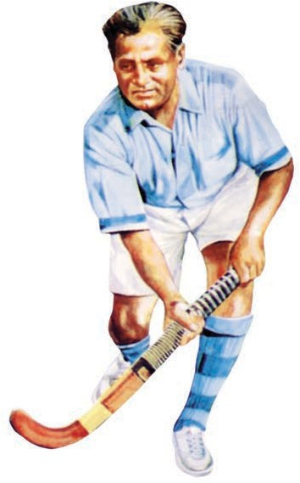

and rank in the German army, if he agreed to play on behalf of Germany, but Dhyan Chand turned down the offer. After the celebrated victory in the Olympics, Hitler awarded a special gold medal to Dhyan Chand.

You may be aware that hockey is our national sport. Major Dhyan Chand’s birthday, August 29 is celebrated as National Sports Day in India. The famous national stadium in Delhi is named after the great hero ‘Dhyan Chand’. Who knows, perhaps one of you may carry the legacy of Dhyan Chand further and win great glory for our country.

*- Adapted from ‘Major Dhyan Chand’ by Sanjay Dudhane, Sports Writer.*



The lifeless hockey stick used to come alive in the hands of Dhyan Chand. When he dribbled, the ball just wouldn’t leave his stick. Some people even stole his sticks and broke them open to see whether they contained a special glue or magnet. Dhyan Chand was even made to play with other ‘ordinary’ sticks but even then his play was as charismatic as ever.

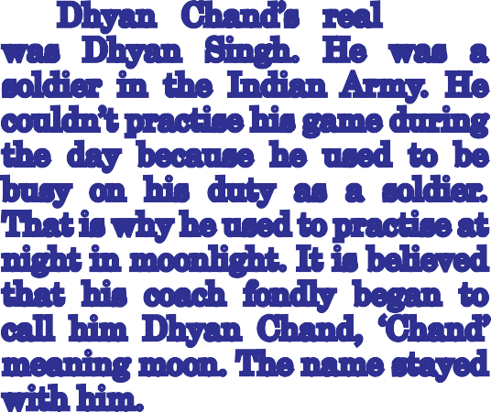

Dhyan Chand’s real name was Dhyan Singh. He was a soldier in the Indian Army. He couldn’t practise his game during the day because he used to be busy on his duty as a soldier. That is why he used to practise at night in moonlight. It is believed that his coach fondly began to call him Dhyan Chand, ‘Chand’ meaning moon. The name stayed with him.

**Things to do :**

1. **Guess the meaning of the following words.**

* water-logged * postponed * novel * barefoot * fruitless * pounced

1. **Name the following.**
   1. Hosts of the 1936 Olympic Games
   2. Ruler of Germany
   3. Not comfortable with the wet ground
   4. Scored the first goal in the match
   5. Did not let the passes go waste
   6. Captain of the Indian Team
   7. Pounced on Dhyan Chand and hurt him
   8. Third time winners of the Olympic gold medal for hockey
2. **Activity**

* Find out how the following games are played.

* Lawn Tennis * Table Tennis * Kabaddi * Kho-Kho

* Hockey * Football * Badminton

1. **Language Study (See pages 84-88.)**

Read the highlighted words. They are .

verbs

hurt

pounced

The goalkeeper

on Dhyan Chand and

him.

Now find at least 5 other verbs from the passage.

1. **Use the following phrases in your own sentences.**

* be sure of * try one’s level best * at any cost * turn down the offer.

## Peer Profile

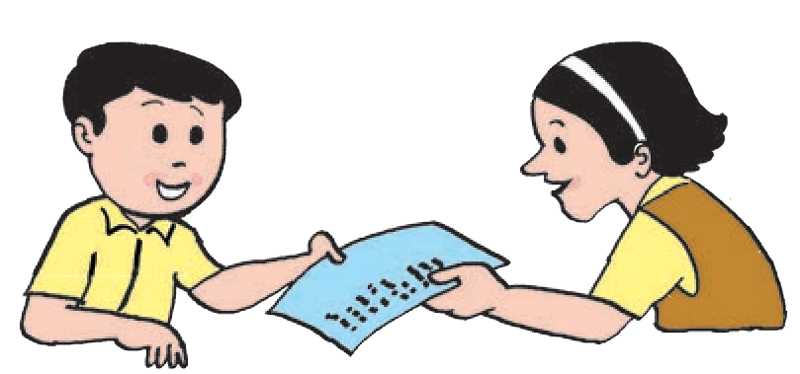

**Project**

Get ten of your friends to fill in this sheet for you.

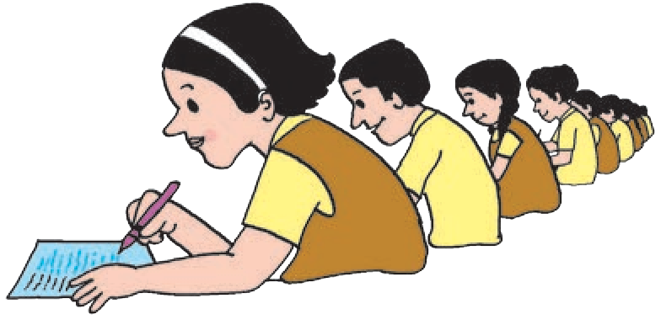After you have collected the filled in sheets from your friends, go through all of them and make notes for each of the points. Use the notes to write a ‘report’ about your friends’ likes, dislikes, habits, favourite personalities, etc. You can present your report orally or in writing.

Remember the following things when you make a written / oral presentation.

* You need not mention the names of your friends in your presentation. You should only give **a summary** of what you observe in the responses given by many people.
* Your presentation should clearly show what **many** or **most** people enjoy, appreciate, fear, etc ; what **only some of them** mention, and what only **one** or **two** mention.
* If necessary, you may point out what is **not** mentioned by any of the people. For example, you may say, ‘It appears that nobody is afraid of examinations, as no one

has included them in the things they fear !’

* You should also mention **what you found most interesting** in the responses, at the end of your presentation.

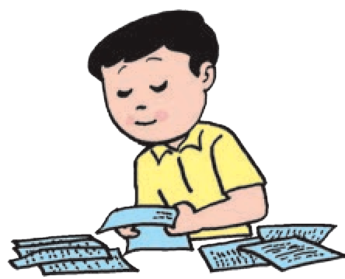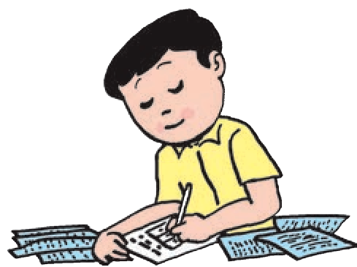

* You must take care to see that you do not hurt anyone’s feelings when you get the sheets filled or when you make your presentation.



This is a language oriented project and therefore it is necessary that students do it independently, using many language skills like approaching people politely, putting together the information gathered under the proper categories in a relevant manner, preparing a report on what they observe and presenting the report briefly but in an interesting manner. Some children should be allowed to present the report orally in the classroom.

The teacher should see that personal remarks are not made during the preparation and presentation of the reports.

## The Triantiwontigongolope

**Unit Two**

There’s a very funny insect that you do not often spy, And it isn’t quite a spider, and it isn’t quite a fly;

It is something like a beetle, and a little like a bee,

But nothing like a woolly grub that climbs upon a tree.

Its name is quite a hard one, but you’ll learn it soon, I hope. So try:

Tri-

Tri-anti-wonti-

# Triantiwontigongolope.

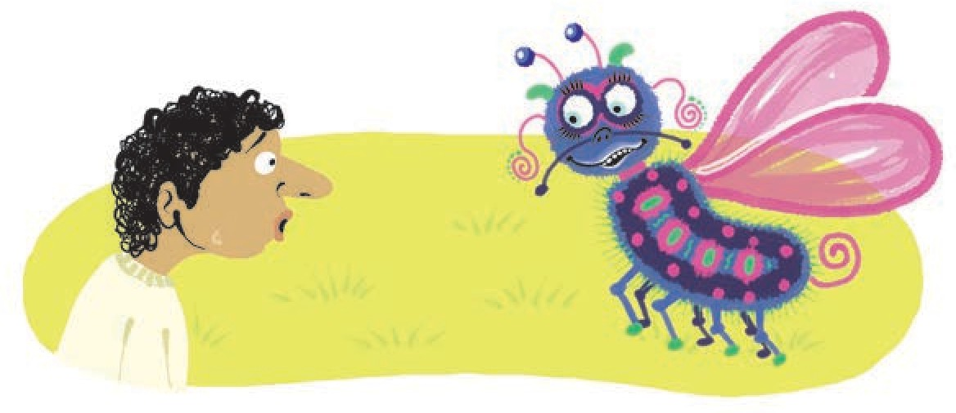

It lives on weeds and wattle-gum, and has a funny face; Its appetite is hearty, and its manners a disgrace.

When first you come upon it, it will give you quite a scare, But when you look for it again, you find it isn’t there.

And unless you call it softly it will stay away and mope. So try:

Tri-

Tri-anti-wonti-

# Triantiwontigongolope.

It trembles if you tickle it or tread upon its toes; It is not an early riser, but it has a snubbish nose.

If you sneer at it, or scold it, it will scuttle off in shame,

But it purrs and purrs quite proudly if you call it by its name, And offer it some sandwiches of sealing-wax and soap.

So try:

Tri-

Tri-anti-wonti-

# Triantiwontigongolope.

But of course you haven’t seen it; and I truthfully confess That I haven’t seen it either, and I don’t know its address.

For there isn’t such an insect, though there really might have been If the trees and grass were purple, and the sky was bottle green.

It’s just a little joke of mine, which you’ll forgive, I hope. Oh, try !

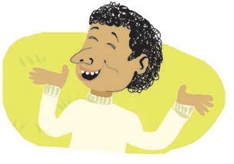

Tri-

Tri-anti-wonti-

Triantiwontigongolope.

*- C. J. Dennis*

**Things to do :**

1. **Read the poem aloud using proper intonation.**
2. **Note that we say ‘its appetite’, ‘its manners’ and not ‘it’s appetite’ or ‘it’s manners’.**

**its**

**means ‘It is’ and**

**It’s**

1. **Activities**

**means ‘belonging to it’.**

* 1. Is the insect described in the poem a real insect ? Think about an imaginary creature. Describe it in your own words. You may draw its picture and label it.
  2. Think of other funny names for imaginary creatures. Write any 3 of them.

## Three Sacks of Rice



You may have read many stories about three brothers. Usually, two of them - the elder ones are strong, clever but unkind. They laugh at the youngest one because he is too simple and soft- hearted.

Our story also has three brothers who lived in a small town but they were all three of them honest, kind and hard- working. The elder one ran a shop, the middle one was a priest and the youngest one had just finished his education. He had started taking up odd jobs to earn some money and to learn a trade. All three of them were fond of their mother. She had worked hard to bring up the three of them after the sudden death of their father.

One day, their father’s friend visited the mother. He said, “Sister, you know that I have a very prosperous business.

But now I am getting old, and my only daughter is of a marriageable age. I am looking for a son-in-law who would be a good husband to my daughter and who would also handle my business well. I like all your sons. If you permit,

I’ll marry my daughter to one of them but before that I have a plan.”

He discussed the plan with her and she agreed quite readily.

The next day, the friend went to each of the three brothers one by one. He gave them each a sack of rice and said, “My dear boy, I am going away for a few months for some necessary work. Please look after this sack of rice till I come back.”

The friend went away. Many months passed but he did not return. It was nearly a year before he came back. He visited the eldest brother first. The eldest brother welcomed him and gave him a small purse full of money. “Uncle, you had left a sack of rice with me. After a few months, I was worried that it may get spoilt. Therefore I sold the rice to my customers. Here’s the money I got. Please accept it.”

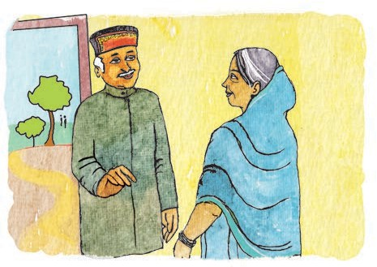“Thank you, my boy, you are such an honest person !”

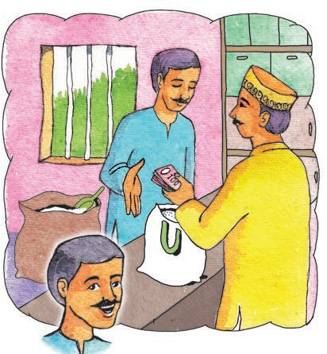

Then the friend went to see the middle brother, who was a priest. The priest greeted him with joy and affection. He said, “Uncle, remember you had left a sack of rice with me, an year ago ? I had kept it for many months, but then I was worried that it may get spoilt. I distributed the rice among the poor in your name. They all blessed you for satisfying their hunger. However, I did that without your permission and I am willing to pay you back for the rice.”

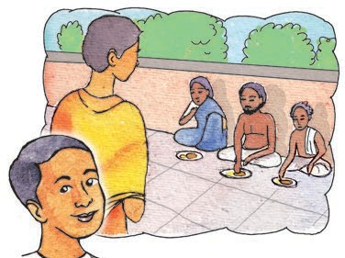

“No, my boy, you acted wisely and kindly. The blessings that I got from the poor people are enough for me. Please don’t even think about the money any more.”

When the friend went to visit the youngest son, he, too, welcomed him with love and respect. But he said that

he had a confession to make. “The sack of rice was lying with me for a long time. But then I had an idea. I often go to a neighbouring farm to help with the work. I borrowed an unused plot of land from the farmer. I exchanged the sack of rice for paddy and sowed the paddy in the plot. Fortunately, the crop grew well and yielded twenty-five sacks of rice. I have kept back five of the sacks and sold twenty of them. Here’s the money. If you allow, I would like to keep a part of it as my share considering the labour and money I spent to get it all done.”

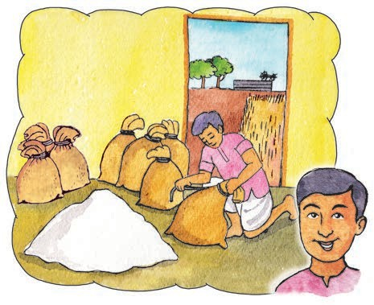

A wide smile spread on the friend’s face. He had found his future son-in- law.

**Things to do :**

1. **Find the opposites of the following words from the lesson.**

* begun * bought * reject * eldest * lent * earned * narrow

1. **Answer the following questions.**
   1. What common qualities did the three brothers have ?
   2. What was the businessman looking for ? Why ?
   3. How did the middle brother use the rice ?
   4. Was it right for the youngest brother to ask for a share in the money ? Why ?
2. **Language Study (See pages 84-88.)**
   1. Read the highlighted words.

hardworking

* + - All three of them were
    - You are such an

honest

,

person.

kind

honest

and .

The highlighted words are adjectives .

Now find at least five other adjectives from the lesson.

* 1. List as many words as you can that will go with the given **adjective**. (At least 3 each.)

**Example :** - sudden change, sudden shower, sudden fall

sudden

* simple * odd * only * honest * long

1. **Activities**
   1. Imagine you are one of the three brothers. Write in short what you did with the rice.
   2. Find any other story of three brothers or three sisters and rewrite it in your own words.
   3. Find out how rice is cultivated. Describe the process with the help of pictures or diagrams.
2. **Group Work**

Form a group of 4 or 5. Make a ‘storyboard’ for the story ‘Three Sacks of Rice’. Arrange the story in the form of a sequence of pictures.

Decide what you will show in each picture; what words / lines you will write with each picture to explain what happens in it.

You can also add ‘speech balloons’ for the people in the pictures.



## Be a Good Speaker



Some people are good speakers. Some are shy. Some speak easily with their friends and relatives, but become nervous in front of a big audience. What about you ?

It is important to be able to speak well. And if you make up your mind, it is not very difficult to do so.

#### Remember these few things when you speak :



* Speak clearly. Don’t mumble.
* Look at the person/persons when you talk to them.
  + You should not be too loud or too soft,

too fast or too slow.

* + - Be polite, and be pleasant.
* Give a thought to the other person’s

feelings and interests.

**When you take part in a discussion :**

* Don’t keep talking all the time.

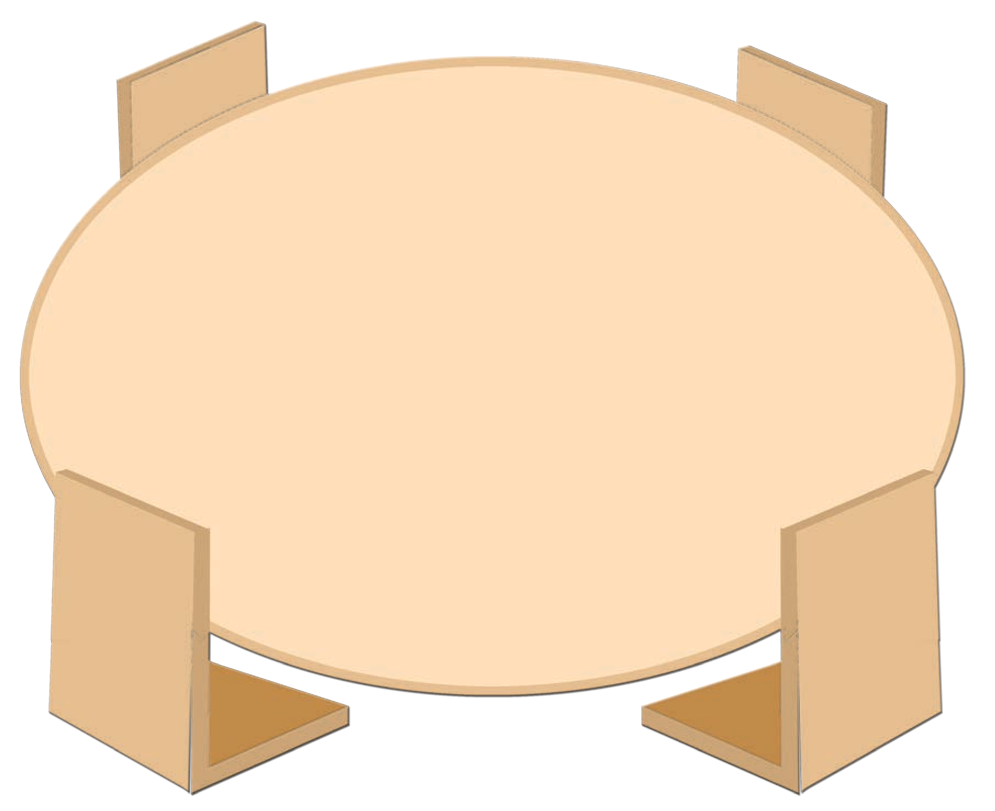

Let others speak.

* Show interest in what others say

and listen carefully.

* When you agree with others or like their ideas,

do tell them that.

* Do share your own thoughts and ideas with others.
  + If you do not understand something,

ask for an explanation politely.

* + - Use polite words and expressions

when you want to interrupt someone, when you disagree with someone,

or when you seek explanations and give them.

26 Unit 2

#### When you want to give a speech :

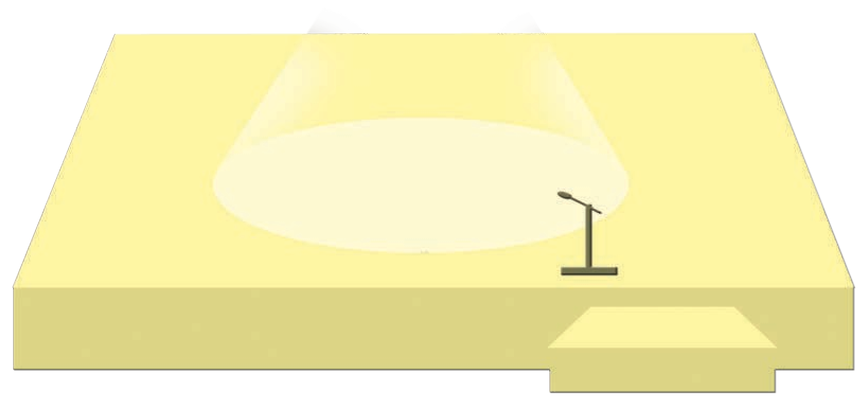

* Plan your speech in advance.
* Note the points and arrange them properly.
  + Rehearse the speech in your mind,

and go ahead.

**Things to do :**

1. **List and say whether the following statements agree with the passage or not.**
   1. You should always speak softly but clearly.
   2. In a discussion, you should share your ideas with others.
   3. If you don’t understand something, don’t let the others know about it.
   4. You should try to talk most of the time whenever there is a discussion.
   5. You should look at the person you are talking to.
   6. When you want to make a speech, there’s no need to think about it in advance.
2. 



**’**



1. **List the polite expressions we use such as ‘Pardon’.**
2. **Look at the speaker in each picture. Say whether each one is a good speaker. Give reasons for your answer.**

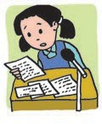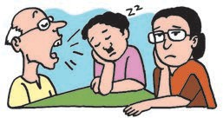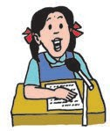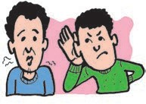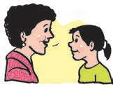

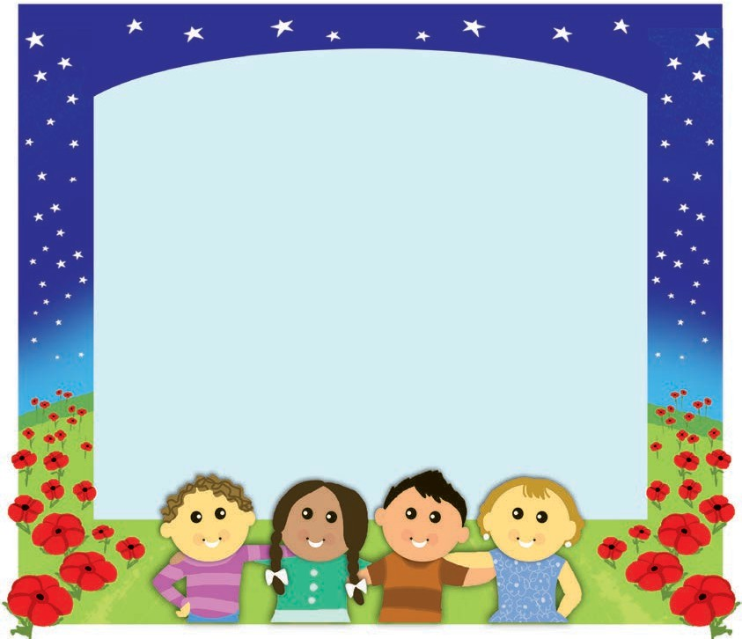

**12. Count your Garden**

Count your garden by the flowers; Never by the leaves that fall;

Count your days by golden hours; Don’t remember clouds at all.

Count the nights by stars, not shadows; Count your life by smiles, not tears;

And with joy on every birthday, Count your age by friends, not years.

**Things to do :**

1. **The following things are mentioned in the poem. Classify them as happy and sad things.**
   * flowers - falling leaves * golden hours - clouds
   * stars - shadows * smiles - tears * friends in your life - passing years.
2. **Name a few other things that people often count. (At least 5.)**
3. **Group Work**

* Discuss how you will measure the worth of -

* a book * a sports event * a friend * a journey. You may find the following pairs useful in your discussion.

difficult words - interesting things / knowledge

defeats - enjoyment

quarrels - sharing feelings and thoughts, problems

obstacles - learning new things, seeing new sights.

## 13. The Adventures of Gulliver

*****Gulliver’s Travels*** *is an interesting book written by a well-known English writer, Jonathan Swift, in which he describes the voyages of Gulliver to various lands like Lilliput and Brobdingnag. Though the character of Gulliver and these strange-sounding lands are imaginary, Gulliver’s experiences and adventures are written so well that they seem real and true to life.*

*Gulliver, the story tells us, worked as a surgeon on ships. As such, he made several voyages. In May 1699, he sailed on the ship ‘The Antelope’. On the return journey, in November, a violent storm sank his ship and Gulliver swam to save his life. Late in the evening, he found himself marooned on a strange land. Weak and exhausted, he slept for about nine hours. It was daylight when he awoke.*

*Let us read what happened next in his own words.*

#### Gulliver Meets the Lilliputians

‘I tried to get up from the ground, but I could not move ! I was lying on my back. Then I found that my arms and feet were held down to the ground with strings. My hair, which was long, was held down in the same way. Thousands of strings had been passed across my body, so that I could not move any part of me, but could only lie there on my back looking up at the sky.

In a little time, I felt something alive moving on my foot. Then it came over

my body and up to my face. Turning my eyes down as much as I could, I saw a man. He was not half a foot high. By his dress, he seemed to be a soldier. Then there came forty more, following the first.

I was so much surprised that I gave a great cry. Then they all ran back in great fear ; and (as I was told later) some of them were hurt in jumping down from my side on to the ground.’

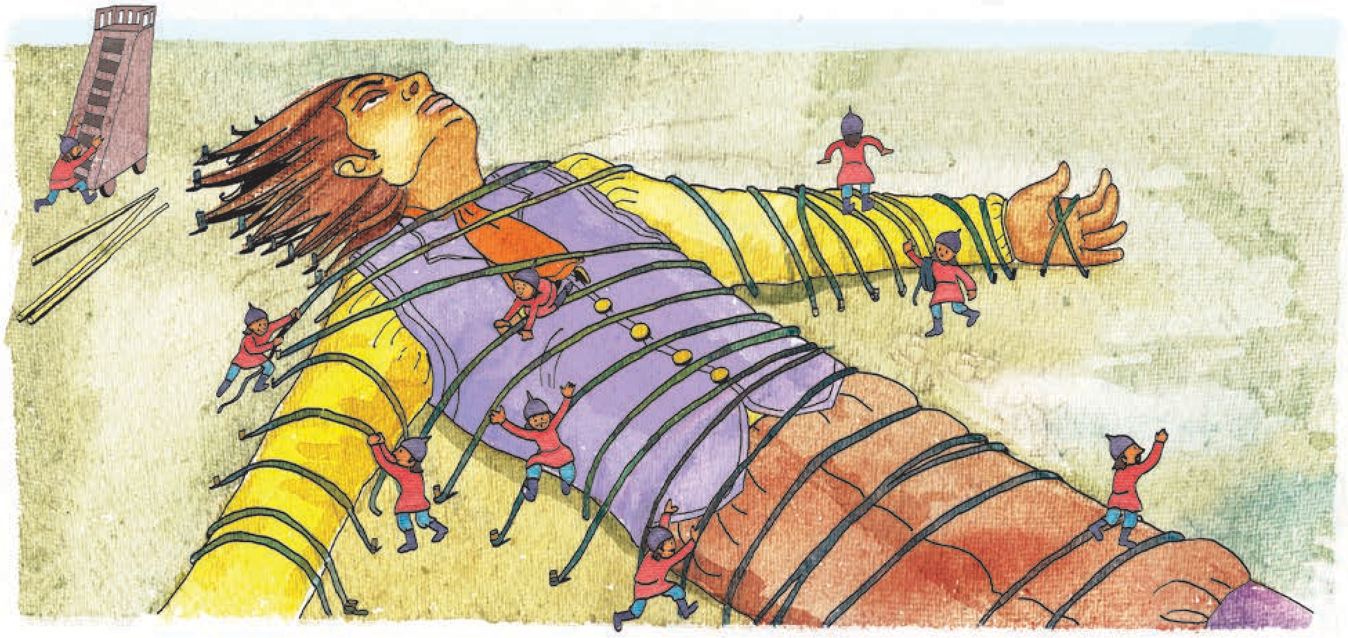

Unit 2

29

#### Gulliver Attempts to Pull Free

‘After pulling very hard I got one arm up from the ground. I also raised my head; this gave me great pain for many of the hairs were pulled out. I put out my hand to catch some of the little men; but they ran away before I could close my hand on them. Then I heard a noise, and felt a pricking in my hand like that of a thousand needles. I found that they were shooting arrows at me. I was afraid for my eyes. I put my hand over my face. After this, I thought that the wisest thing

to do was to lie quiet till night. I thought that then, my hand being free, I could quickly set free the rest of my body.

Soon a platform was raised and an important-looking man gave a long speech. From his gestures, I guessed that he was trying to tell me that they would not harm me, if I did as they told. I too, replied with gestures that I would remain quiet. I also told them that I was hungry.’

***

#### Gulliver Eats a Giant Meal

‘At once, a hundred men climbed up on to my body and marched up to my mouth, carrying food. The bread was as small as bullets. So I ate two or three loaves at a time and cries of surprise rose from the Lilliputians that I should eat so quickly and so much. The Lilliputians were no longer afraid of me. They danced upon my body and ran to and fro. I could have caught at least forty of them with my hands and thrown them down. But I remembered

my promise to remain quiet. Indeed, I was surprised at their bravery for I must have seemed the greatest giant in the world.

Later, I was taken to the city where the king lived. A great cart was made by joining many carts. Nine hundred men worked for three hours to put me on to the cart which was drawn by fifteen hundred of the king’s finest horses. The city was just half a mile away but the journey took almost a full day.’

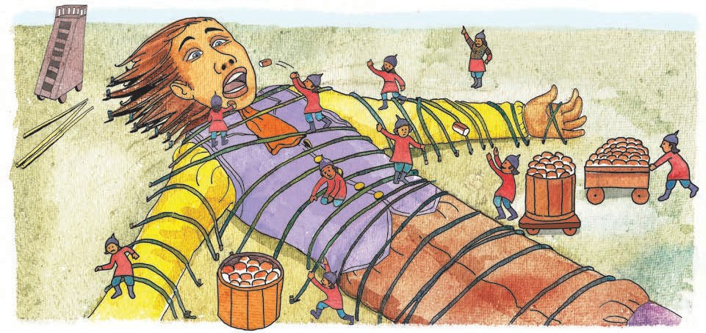

#### Gulliver’s New Home

‘The king came out to meet me; he came near and looked at me, but it was not thought safe for him to climb up on me.

At the place where the cart stopped there was an old church. It was the largest building in the whole country. For certain reasons, it had not been used as a church for many years. It had now been made ready for me to use as my house. The great door on the north was four feet high and two feet wide. So, I

could go into it by going down on my hand. One of my feet was set in a great ring on the end of many strong strings so that I could not get away, but could only walk some distance outside my door. The country outside looked like a garden.

After some days, the king and his people were convinced that I would not harm them. So, after I agreed to keep certain ‘orders’ of the king, I was allowed to move around.’

***

#### Gulliver Visits the City and the Queen

‘As soon as I was set free I asked if I might see the city. The king was pleased to let me do this. Orders were given to all the people to remain in their houses. I then stepped over the wall, and went very carefully, along the two largest streets. All the windows were full of faces looking out at me, and large numbers of people were standing

on the tops of the houses. The king’s house was just at the place where two great streets met. There was a beautiful garden on all sides of it. Lying down in the garden I put my eye to the windows. The rooms inside were very beautiful. In one room, I saw the queen and some of the young princes. They were greatly pleased by my visit.’

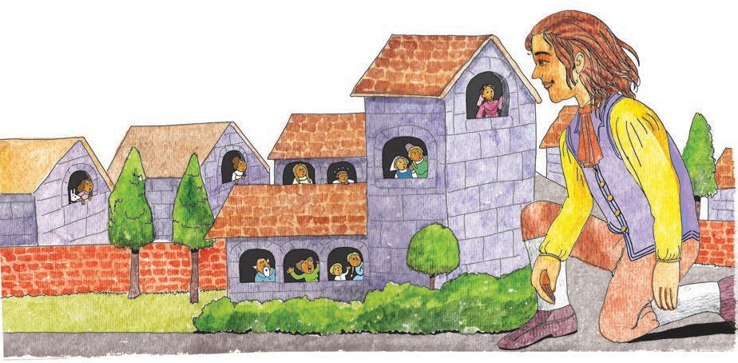

**Things to do :**

1. **Answer the following questions in short.**
   1. How was Gulliver tied down on the seashore ?
   2. What did the important-looking man tell Gulliver ?
   3. How was Gulliver taken to the city ?
   4. Describe Gulliver’s home in Lilliput.
   5. Describe Gulliver’s walk around the city.
2. **Activities**
   1. Tell any one of the stories orally imagining you are Gulliver.
   2. Write any one of these stories, not as told by Gulliver, but by some other person.
   3. Imagine that you are in a land of tiny people like Lilliput. Write about some of the interesting things you might see there, including animals, houses, plants, vehicles, etc. Find an interesting name for this land.
   4. If you were to grow very tiny like a Lilliputian, what are the things you would like to do ? Write about any three of these things.
3. **Language Study (See pages 84-88.)**
   1. Read the highlighted words. They are .

adverbs

* + - I was pulling .

hard

* + - They ran away .

Later

, I was taken to the city.

* + - I went very
    - They were

greatly

.

pleased.

carefully

* 1. Find suitable adverbs for each of the following verbs. (At least 3 each.)

* walk * speak * push * study * sing * work

* 1. Find the opposites of the following adverbs.

* hard * quickly * fast * tidily * unknowingly

* early * often * never * honestly * shamefully

***

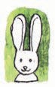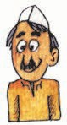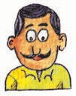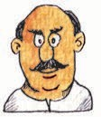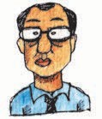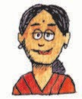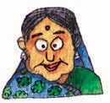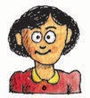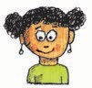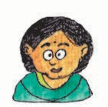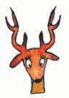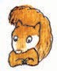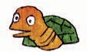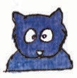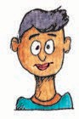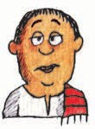

*Hawker*

*School-bus driver*

*Dr Sawant*

*Mrs Patel - a housewife*

*Mr Desai - a businessman*

*Mayor of the town*

*Mrs Joshi - a housewife*

*Nidhi and Madhu - Mrs Joshi’s daughters* (*school-going girls*)

**14. A Lesson for All**

**Characters**

***Humans***

*Rabbit*

*Deer*

*Peacock*

*Squirrel*

***Animals***

*Birds*

*Tortoise*

*Newspaper boy*

*Milkman*

*Bear*

#### A city street, early in the morning

(*The street is littered with plastic bags, cartons, tins, cans, broken glass, old tyres, waste paper balls, bags and other garbage. Enter Mr Desai*.)

**Mr Desai :** (*looking out into the distance*) Why hasn’t the newspaper been delivered on time today ? It’s nine o’clock. Almost time to leave for my office. (*looks out again*) Let me ask the Patels if they have received their copy.

(*Goes into the Wings and returns with Mrs Patel.*)

**Mrs Patel :** No Mr Desai, the newspaper boy hasn’t delivered

the papers as yet. Nor has our milkman turned up ! Mr Patel is so grumpy. He is waiting for his morning cup of tea.

**Mr Desai :** Very strange ! And look ! The state the street is in, is simply shocking.

**Mrs Patel :** My word ! What’s this ? Where did all this litter and garbage come from ?

(*Enter Mrs Joshi with her daughters.*)

**Mr Desai :** I returned rather late from the office last night and the street was bare then. How did all this rubbish gather here overnight ?

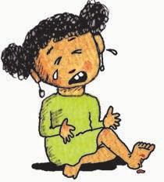(*Suddenly, Madhu falls and injures her foot - gives out a cry of pain.*)

**Madhu :** Oooh ! Ouch ! My foot ! It hurts !

**Mrs Joshi :** Oh dear ! Madhu, are you alright ? Oh, no, her foot is bleeding

so much ! Somebody help, please !

**Mrs Patel :** Nidhi, run and fetch Dr Mrs Sawant. Request her to come quickly. Your sister has cut herself on a broken glass bottle.

**Mr Desai :** I’ll get some ice at once.

**Mrs Joshi :** (*almost in tears*) My poor child ! How did all this broken glass happen to be here ?

**Mrs Patel :** Look around. It’s not just broken glass, but....

**Mrs Joshi :** Dear me ! What nonsense this is ! Unbelievable ! Where has all this rubbish come from ?

(*Dr Sawant enters with Nidhi. She has a doctor’s kit.*)

**Dr Sawant :** Let me see the wound.

**Mr Desai :** Here’s some ice to stop the bleeding.

**Dr Sawant :** What presence of mind ! Good ! (*Applies ice on the wound.*) There now ! It has stopped bleeding. It’s a deep cut. I’ll dress the wound and she will be fine.

**Mrs Joshi :** Thank you, Doctor. So kind of you to come at once. But I am going to complain to the Mayor. Have you seen the rubbish and the litter on the road ?

**Dr Sawant :** Oh, it’s a mystery. All this garbage was not there yesterday. And now..... just look !

(*Enter newspaper boy, milkman, hawker, etc.*)

**Mrs Patel :** The Mayor must not have seen ... Look, the newspaper boy ! He is limping. And the milkman at last ! (*To the milkman*) Why, where’s your bicycle and why are you so late ?

**Milkman :** The tyres were punctured. I had to come walking all the way with this heavy milk can.

**Newspaper boy :** And I tripped over an old tyre and sprained my foot. It was quite dark early this morning. I did not expect an old tyre right in the middle of the road.

**Mr Desai :** I see ! Something must be done.

(*Bus driver enters carefully avoiding the litter.*)

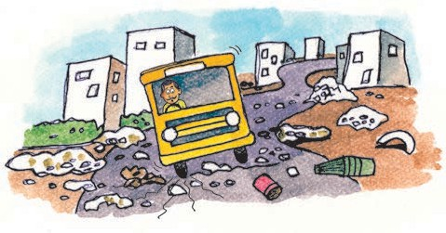

**Bus driver :** Mrs Joshi, Mrs Joshi, I’m sorry. I can’t drive the school bus today. On every road and street there is nothing but litter. It looks like an obstacle race course.

**Mrs Joshi :** I know ! I’m going to send for the Mayor at once. He must see this. Our children are not safe with all these dangerous broken objects around.

**Hawker :** No one is safe. Let’s request the Mayor to come and see for himself.

**Mr Desai :** I’ll fetch him. (*Exit*)

(*Enters again with the Mayor and his retinue.*)

**Mayor :** (*Annoyed*) Unbelievable ! Shocking ! How do you expect people to walk through all this rubbish ? Why don’t you all dispose of the garbage properly ?

**Mrs Patel :** But we do, Mr Mayor. We give our garbage to the garbage collector.

**Mrs Joshi :** Yes, we don’t litter our streets like this.

**Mr Desai :** Or we take it to the dumping ground near the river-

side - away from here. The rains then wash it away.

**Mrs Patel :** Or the winds blow it away.

**Mayor :** Then how did it come back into the town overnight ?

**Bus driver :** That’s the problem ! Nobody knows how it got here. It’s a mystery.

**Newspaper boy :** It looks like someone has done it purposely to spoil our town.

**Mrs Joshi :** And endanger our children.

**Milkman :** And hinder our daily work.

**Mayor :** We will not tolerate this ! I must look into this. I will not spare anyone. Who has done this ? Who is responsible for this mess ?

(*Enter animals who have been hiding*

*- deer, rabbit, birds, squirrel, bear, etc. Each one comes out from its cover turn by turn, saying*)

**Animals :** We are responsible !

We have brought in all the litter.

We have spread the garbage all over the town.

**Deer :** Yes ! We confess we did so.

**Mayor :** What ? You ! How dare you ?

**Mrs Joshi :** What right do you have to spoil our town and make it unsafe to move around ?

**Bear :** (*comes forward*) We have only brought back to you what belongs to you. Tell me, what right do *you* have to dump all this in the forests ? The forest is our dwelling place.

**Birds :** Our trees are dying and vanishing because of you. Where can we roost or build nests ?

**Squirrel :** And where can we live ?

**Rabbit :** You are worried about Madhu being injured because of sharp broken glass - Don’t our young ones get injured too ?

**Deer :** Yes ! And we have no doctor to dress their wounds. Our young ones simply die.

**Madhu / Nidhi :** Oh, no ! How shocking ! Terrible !

**Tortoise :** All the fish in the rivers and lakes die because of the waste dumped in water. How we suffer because of the chemicals and poisons !

**Bear :** And so many animals who drink the polluted water fall ill and die.

**Dr Sawant :** Yes. It is unfortunately true.

**Peacock :** So we called a meeting and decided to return all your dangerous stuff back to you. We don’t need it.

**Bear :** Anyway, we were not as cruel as you are ! We have only returned the garbage. We have not poured chemicals and poisons onto your settlements.

**Mayor :** I see. You animals and birds do have a point. You are right.

**Mr Desai :** You have opened our eyes. We should not dump rubbish in the forests or rivers or lakes.

**Mrs Patel :** But where can we dispose of it ?

**Mayor :** If you all agree to sort out the litter, I will arrange for it to be collected separately. Then, some of it can go for processing and some, for recycling.

**Mrs Joshi :** Good idea ! Let’s do just that.

**Mayor :** Let us save our mother earth from further harm. (*To the animals*) Thank you, dear animals for teaching us a lesson so effectively. We assure you, we will not pollute or spoil your homes. I shall even warn those who go there for picnics.

**Some animals :** Thank you, Mr Mayor ! Thank you. (*They return.*)

**Mayor :** Self-help is the best help. Let’s clear this up. (*All including the Mayor start picking up the litter.*)



*- Curtain -*

36

Unit 2

**Things to do :**

1. **Answer the following questions.**
   1. What difficulties do the people in the play face in the morning ?
   2. What more difficulties would they have to face, if the roads are not cleared ?
   3. What are the complaints of the animals ?
2. **List the characters in the play.**

* Human characters * Birds and animals

1. **Activities**
   1. Enact the play.
   2. Write slogans for the cleanliness drive in your area.
   3. Write a short note / story based on the ill effects of pollution.
2. **Language Study (See pages 84-88.)**
   1. Find two examples of each of the following from the lesson.

* A Statement * A Question * A Command * An Exclamation

1. **Group Work**
   1. Form groups of four or five.

Try to find the answers to the following questions through observation and by talking to your teachers, parents and others. Discuss your answers in the group.

* + - How is waste generated ?
    - How is it removed or cleared ?
    - How can we help in the task of clearing or removing garbage ?
  1. In what way can we help to reduce or minimize waste generation ? Discuss the issue in groups of 4 or 5 and note down all good suggestions.

Resolve to follow them yourself. Some have been given below for your reference.

* + - Don’t waste food.
    - Take as much as you want but finish everything that’s on your plate.
    - Don’t throw away broken or half-used things. Repair them and use them.
    - Avoid things which can be used only once.

For example : thermocol (polysterene) cups, plastic glasses, etc.

* + - Reuse !
    - Recycle !

## 15. Bird Bath



In our garden we have made Such a pretty little pool,

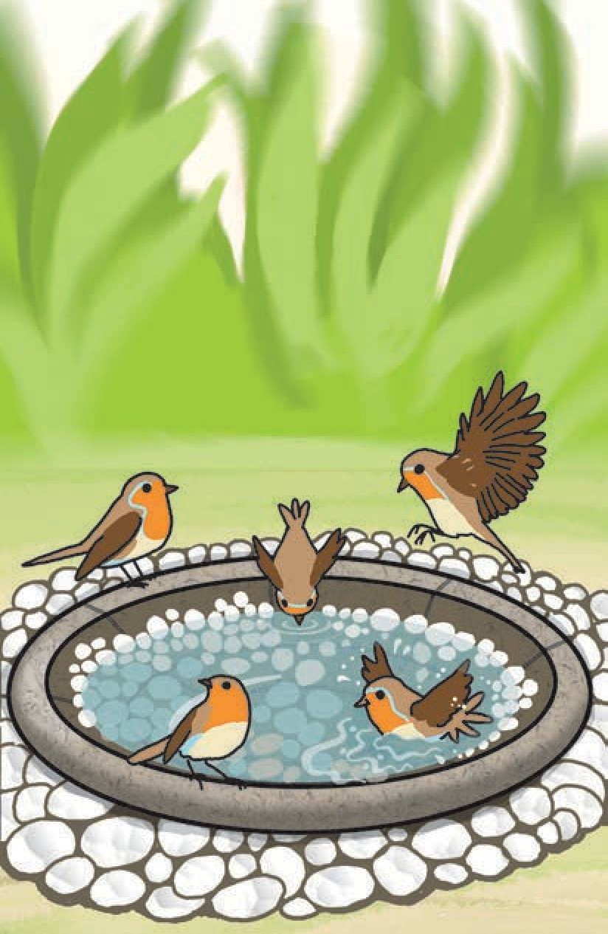

Lined with pebbles neatly laid, Filled with water clean and cool.

When the sun shines warm and high Robins cluster round its brink,

Never one comes flying by But will flutter down to drink.

Then they splash and splash and splash, Spattering little showers bright

All around, till off they flash Singing sweetly their delight.

*- Evaleen Stein*

**Things to do :**

1. **The poem has rhyming words at the end of the lines. Find and write the pairs of rhyming words in each stanza.**
2. **Guess the meaning of the following words in the poem.**

* lined * cluster * brink * flash

1. **Rewrite the following lines in your own words.**
   1. ‘Never one comes flying by But will flutter down to drink.’
   2. ‘till off they flash

Singing sweetly their delight.’

1. **Write what you can do to welcome birds in your surroundings.**
2. **Discuss what you can do to help other animals in your surroundings. Write down any three ideas you like from the discussion.**

Unit 2

38

## 16. Write your own Story



Form groups of five.

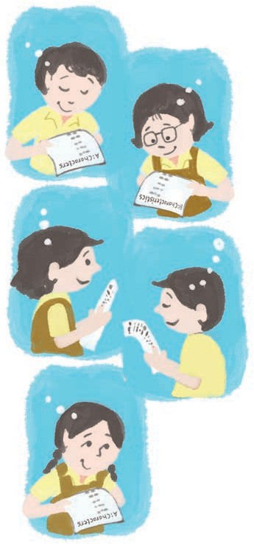

Characters

Characteristics

Story Type

Time

Places

Look at the chart given on pages 40-41.

Each person in the group is given only one column to choose from.

From column A, one person chooses any five characters.

From column B, another person can choose any five characteristics or qualities for these characters.

From columns C, D and E, the three remaining children choose the story type, the period and one setting (place) respectively.

The condition is that every person chooses separately, without telling / consulting the others.

After everyone has chosen, you put all the elements together and build a story / play with it.

It must have a beginning, some events and an end.

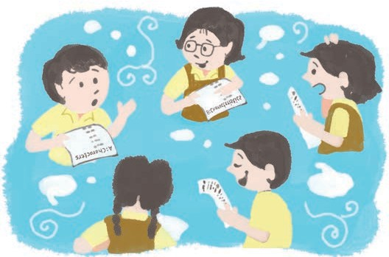

39

**For the teacher :** Discuss the activity in the classroom and demonstrate how

to choose from the columns. Build one story through a discussion

in the classroom. After that, allow children time to build their stories / plays in the classroom itself. Later on, they may write the stories individually or as a

group activity. Encourage them to illustrate their story/play.

You may choose other supporting characters and move from one setting or time period to another, if necessary, but you must use what you choose first.

Unit 2

|  |  |  |  |
| --- | --- | --- | --- |
| **A : Characters** | | **B : Characteristics** | |
| magician | dog | brave | talkative |
| school girl | scientist | coward | silly |
| school boy | a super-hero | wicked | sly |
| mouse | robot | kind | honest |
| thief | detective | weak | cunning |
| soldier | neighbour | bullying | loyal |
| farmer | elf | nosey | rash |
| dinosaur | acrobat | forgetful | helpful |
| merchant | pilot | very intelligent | selfish |
| king/queen | hawker | scholar | strong |

Do you have these elements in your story ?

Good descriptions. (You will need adjectives.)

Events and actions.

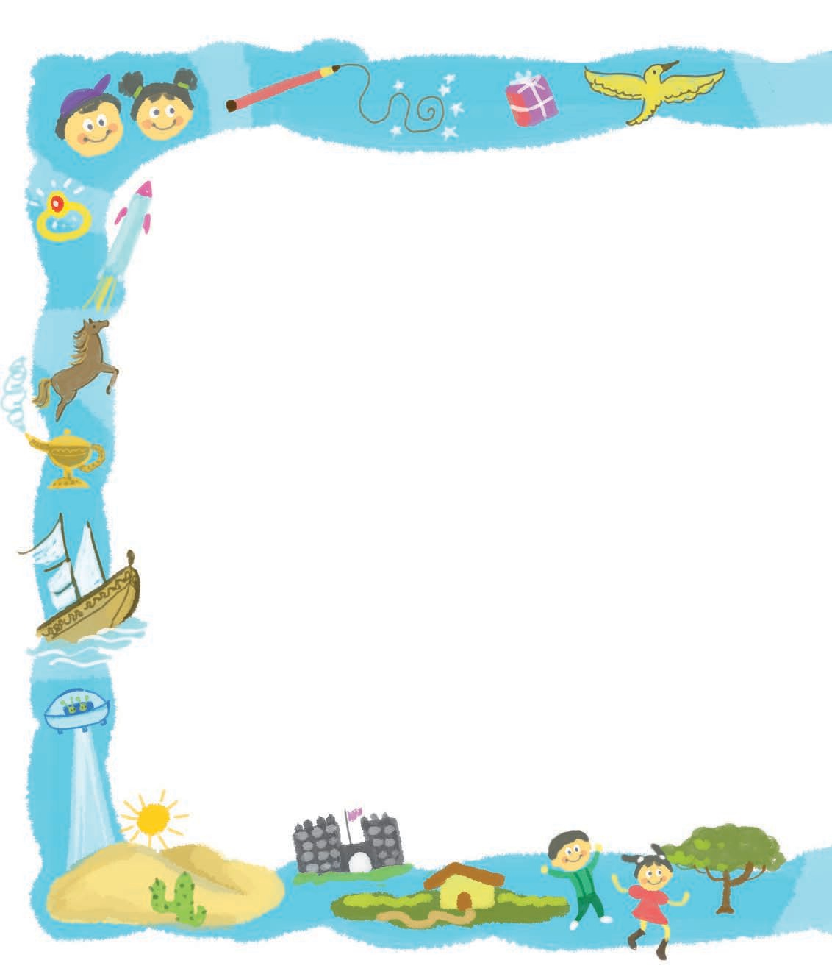

40 Unit 2

|  |  |  |
| --- | --- | --- |
| **C : Story Type** | **D : Time** | **E : Places** |
| fairy-tale | In the time of the caveman | Your city / town / village |
| fantasy  On | ce upon a time | On another planet |
| mystery | One thousand | In a faraway land |
| adventure | to five hundred years ago | In a desert |
| ordinary | Twenty years ago | In the forest |
| success story | Now | In a hill fort |
| funny | Twenty years from now | On an island |
| science fiction | Two hundred | In a big city |
| tragic | years from now | In space |
| play li | When dinosaurs ved on the earth | In a small kingdom |

Dialogues and conversations and also ‘monologues’, if you like.

Some surprise for the readers !

Please share your story with other groups.

Unit 2 41

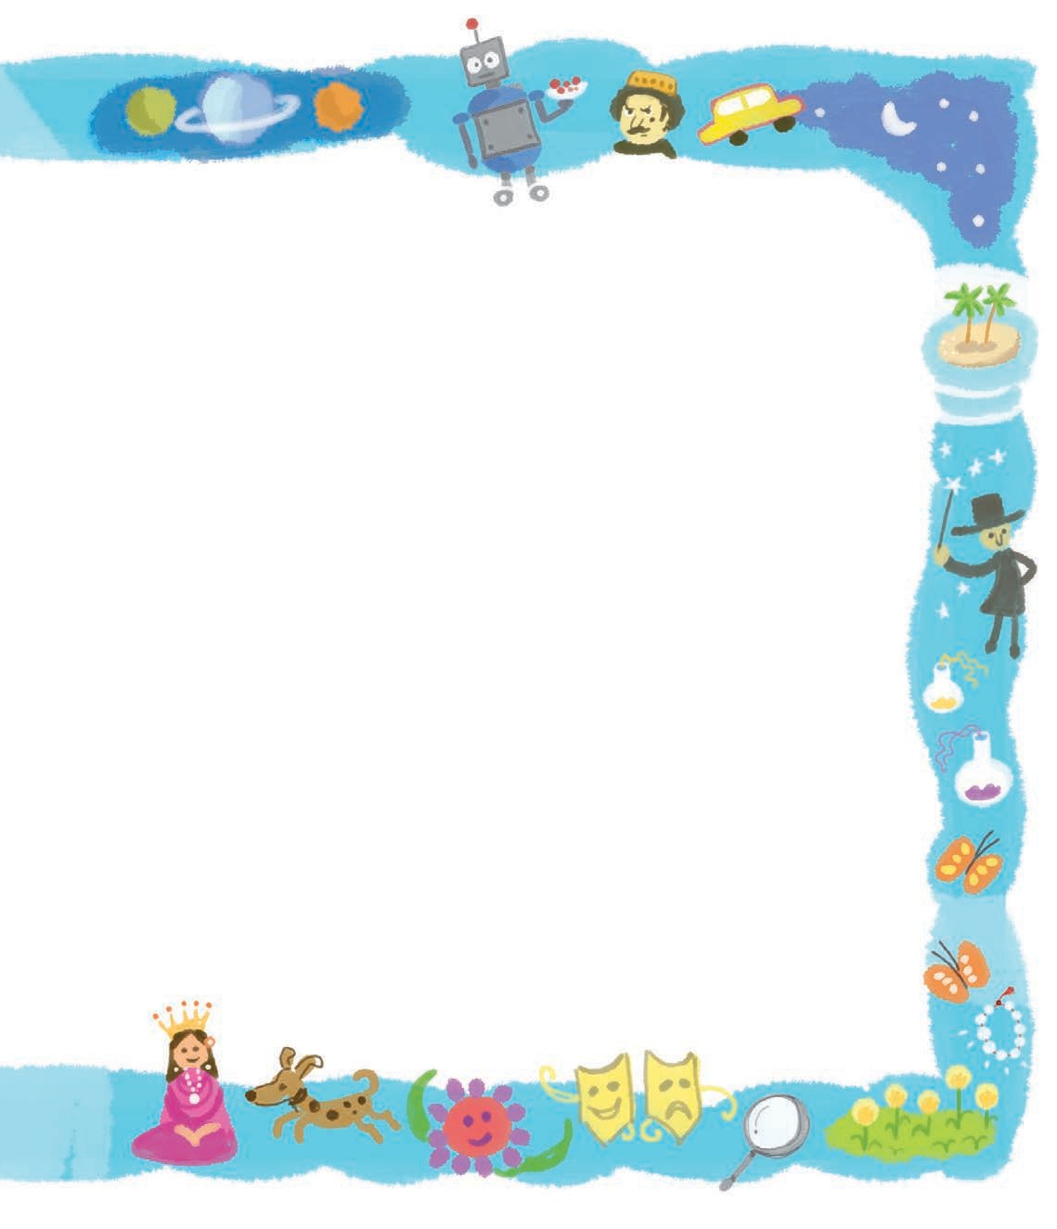

**Unit Three**

## On the Water

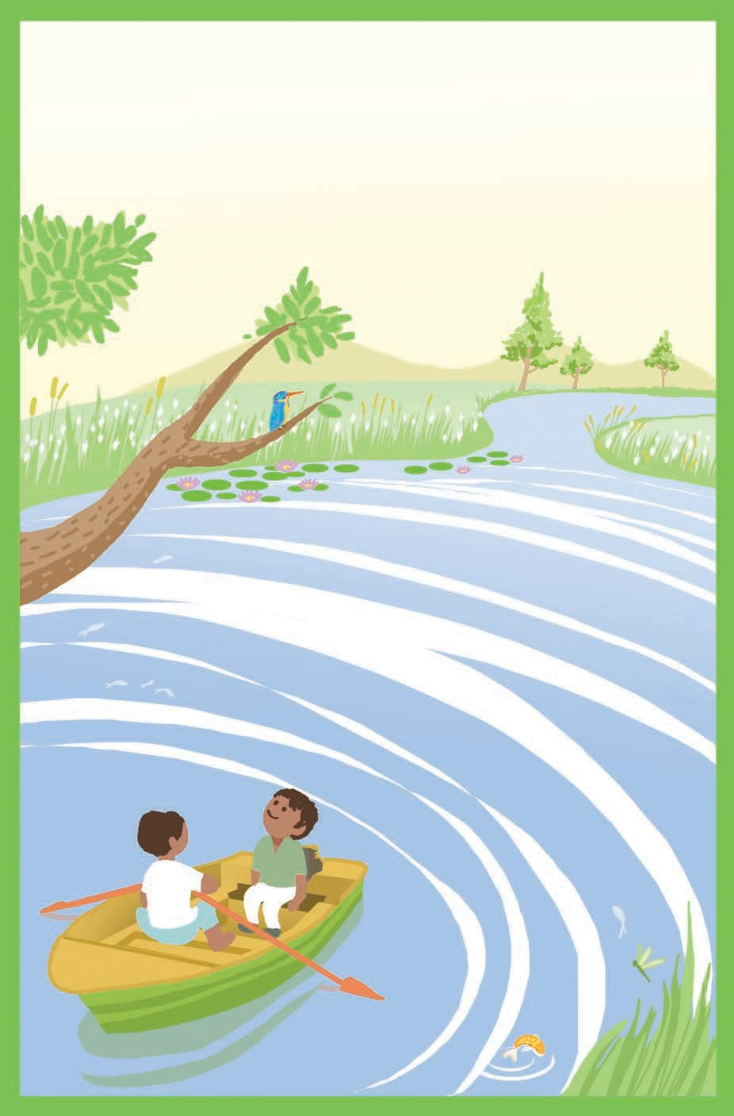

In our little boat to glide

On the water blue and wide,

While the sky is smooth and bright, What could give us more delight ?

See the ripples, how they run, Twinkling brightly in the sun; While reflected we can see Shadows of each hill and tree.

See the lilies, round and large, Floating near the reedy marge, Where the bulrush has its place And the heavy water-mace.

See the great green dragonfly, And the swallow skimming by. See the fishes spring and gleam, Ere they splash into the stream,

See the bright kingfisher too Dart a gleam of green and blue. These are all around our boat On the water whilst we float.

* reedy marge : water’s edge where reeds or tall grasses grow thick.
* bulrush, water-mace : wetland grasslike plants.
* ere : before.
* dart : move suddenly and rapidly.
* whilst : while.

**Things to do :**

1. **Answer the following questions.**
   1. List the insects, birds, trees and plants mentioned in the poem.
   2. List the rhyming words in the poem.
   3. Write what the following do, with the help of the poem.

* ripples * lilies * swallow * fishes * kingfisher

* 1. Write what the poet is doing.

Does the poet like the experience ? Write the line which tells us about it.

1. **Activities**
   1. Write a short essay on your own journey in a boat.
   2. Prepare and present a speech on ‘My Favourite Place’. Use the following points.
      * Name of the place
      * Its special features
      * The reason why you like it
   3. Make a painting or a collage to show the different things described in the poem.



## Weeds in the Garden



Most of the parents like to fulfil the wishes of their children. They feel sorry when they cannot indulge their kids or when they have to scold them. And when even a scolding has no effect, the parents become very very unhappy. Such was the case with Anshuman and his parents.

Anshuman’s parents had noticed that he was developing some bad habits. Naturally, they began to warn him time and again, but all in vain. Anshuman just wouldn’t listen. He refused to believe that he was letting those bad habits get a hold over him. Gentle words, strict warnings, a scolding now and then - his parents tried everything short of beating him up. And that they would never do. However unhappy they themselves were, they wanted to be loving and gentle as they tried to correct their son’s ways.

Soon, an opportunity presented itself. Anshuman had gone to stay on his grandfather’s farm with his parents. Early one morning, his father took him

for a walk around the farm. He was describing

the specialities of various plants and vines and bushes and trees to Anshuman. Suddenly, he stopped and pointed at a small seedling growing near a plant.

“Anshuman, that’s a weed. Can you pull it out ?”

Anshuman had no difficulty in pulling all of the small seedling out. “Good !” said his father and they continued with their walk. After a while, they came upon the same weed but there, it had grown slightly bigger. Anshuman’s father told him to pull out this plant, too. He told him to uproot the weed carefully, making sure that no trace of the root was left in the soil.

“Otherwise the weed can grow again,” he warned.

Anshuman uprooted the plant carefully, twisting it and pulling it hard so that the whole of it came out.

Then his father drew his attention to the same weed growing at some

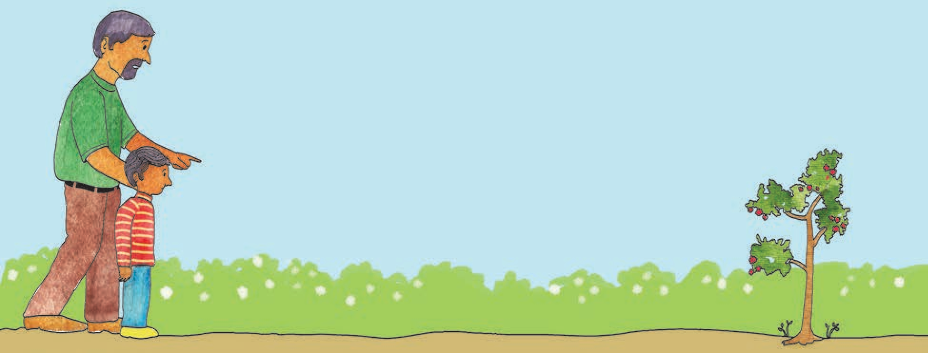

distance. There, it had grown into a big plant with tiny flowers and dark fruit.

“That could be quite dangerous. We mustn’t leave it growing there. Take it out,” said Anshuman’s father.

Anshuman held the plant in his hands and gave it a tug. The weed didn’t move at all. He pulled harder and harder but to no avail.

“I can’t get this out !” exclaimed Anshuman. “It has gone too deep into the soil.”

So then his father brought some implements, they dug around the weed and with great effort, pulled it out.

When they were returning home after the hard work, Anshuman’s father mentioned, “Habits are like weeds. The

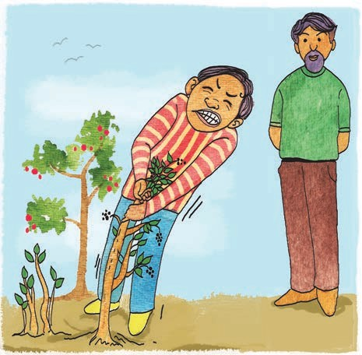

longer you allow them to grow, the harder it is to uproot them. It is wise to get rid of them when it is easy to do so.”

Anshuman realized the truth in his father’s words. Throughout his life, he never forgot that early morning walk on the farm with his father.

**Things to do :**

1. **List all the words and phrases in this story that indicate ‘time’.**
2. **Add proper prefixes like up- , un- , dis- , in- to the following to form opposites.**

* happy * root * effective * noticed * believe * civilized * continue

1. **Answer the following questions.**
   1. When do the parents feel sorry and become unhappy ?
   2. What methods did Anshuman’s parents use to warn Anshuman about his bad habits ?
   3. What did Anshuman’s father compare bad habits to ?
2. **Use the following phrases in your own sentences -**

* in vain * get a hold of * to get rid of.

1. **Language Study (See pages 84-88.)**
   1. Read the highlighted words. They are known as prepositions .



of

around

*

*

a walk *

the soil *

with



in



for

the farm * specialities great effort

plants

* 1. 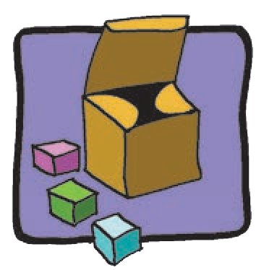Change the meaning of the sentences by changing the preposition.

The tiger jumped into the river.

Put the cubes in the box.

We travelled to Mumbai by train.

There were many people around the house.

The children were asked

to come without their parents.

* 1. 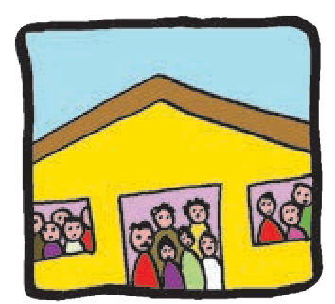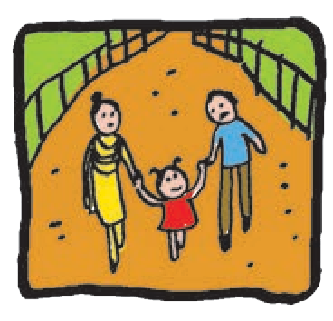Change the meaning by changing the adverb.

* Speak gently. * Come in. * Hit the stone hard with the hammer.

1. **Group Work**
   1. Form groups of 5-8 and list the following.
      * Bad habits
      * Very harmful habits
   2. Discuss the following in groups.
      * Do people admit that they have bad habits ?
      * What can we do to get rid of bad habits?
      * Do’s and Don’ts for young children.

***

## Be a Good Host and Guest







#### If you are the host, these are the things that you should remember to do :



Let’s have a surprise party for Grandpa.

Consult your family members first and see whether they like the idea. They will help you to choose a suitable time, date, place, menu, etc.

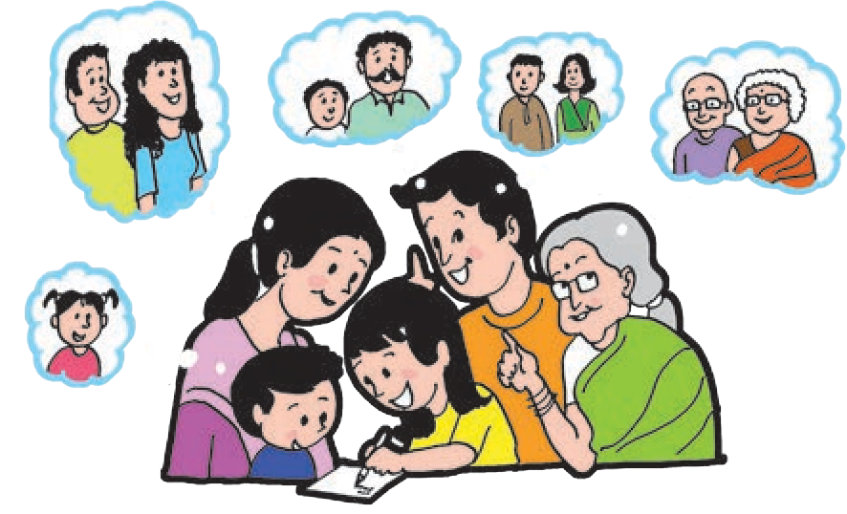

Make a list of the people you wish to invite to the party.

Send the invitations well in advance. You may extend an invitation orally or you may send a written invitation. Make sure that your invitation includes all the necessary information -

* Who is inviting whom.
* The occasion why you are giving the party.
* When and where it will be held - what day, what time, what place.

Unit 3 47

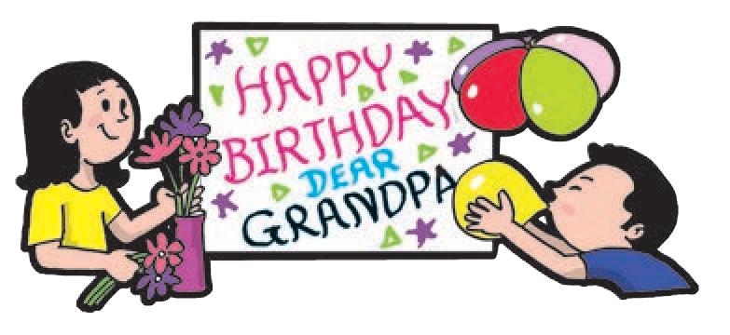

Do you want any decorations ? How will they be done ?

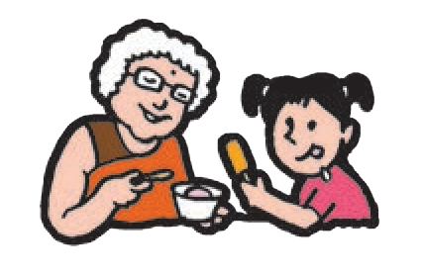

Choose a ‘menu’ that your guests will enjoy. (Remember the story of the fox and the crane ?) As a good host, you should consider your guests’ preferences first.

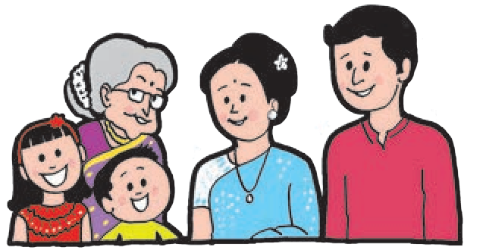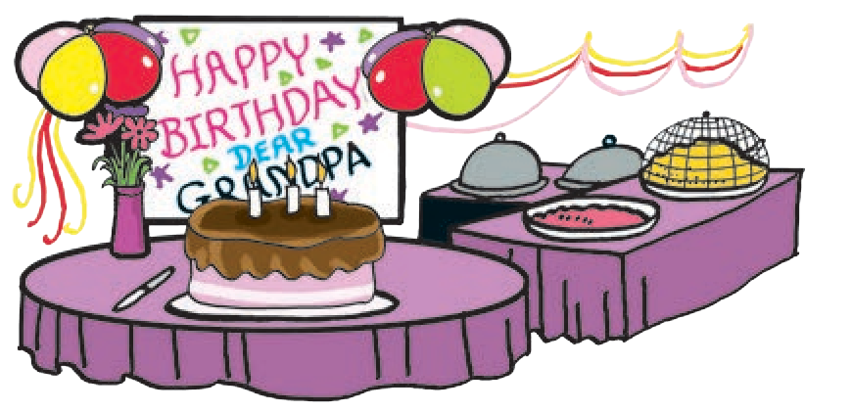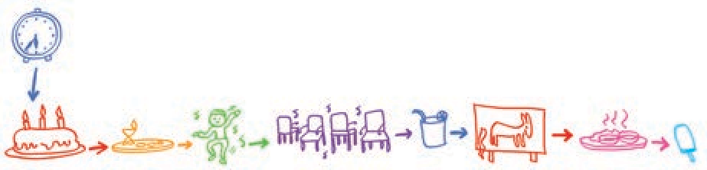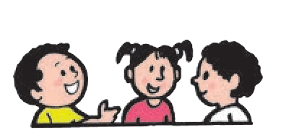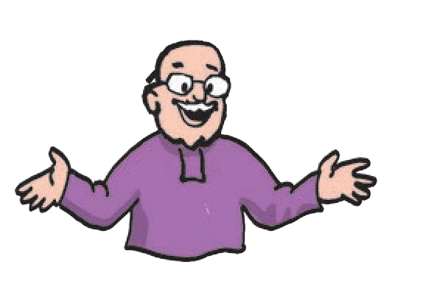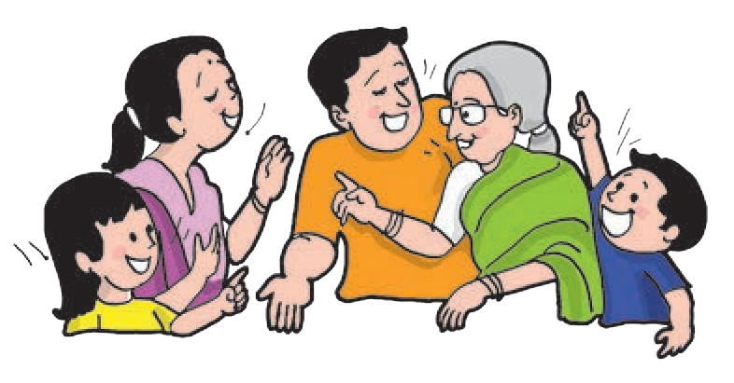

Once you have planned the above details, you can work out how the various tasks can be done - who will help you to do each of them.

Wow ! Great !

What a surprise !

**On the day of the party :**

* You must be ready before your guests.
* Your decorations, food preparations should be ready before the people arrive.

Hi !

Hi !

You must greet all your guests when they arrive. If they don’t know one another, you must introduce them.

•

Chalk out a ‘programme’ - will you begin with games or music ? When will food be served ?

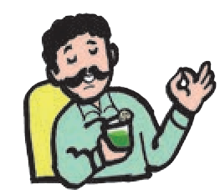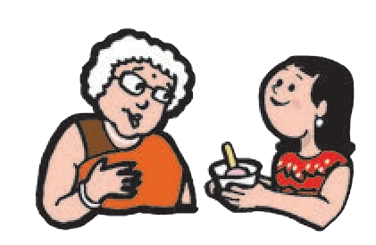

48

Unit 3

* You should serve the food politely, making sure that everyone is served what they want.
* You should see that all your guests are comfortable and happy.
  + If you are holding party games, make sure that everyone gets a chance to participate and enjoy.

Here are some common party games :

**Simon says**

Hands up !

**Musical Chairs**

**Hot and Cold (Guessing game)**

**Whispers**

Hindi or English ?

**Charades**

Four words ?

**Pin the tail on the donkey**

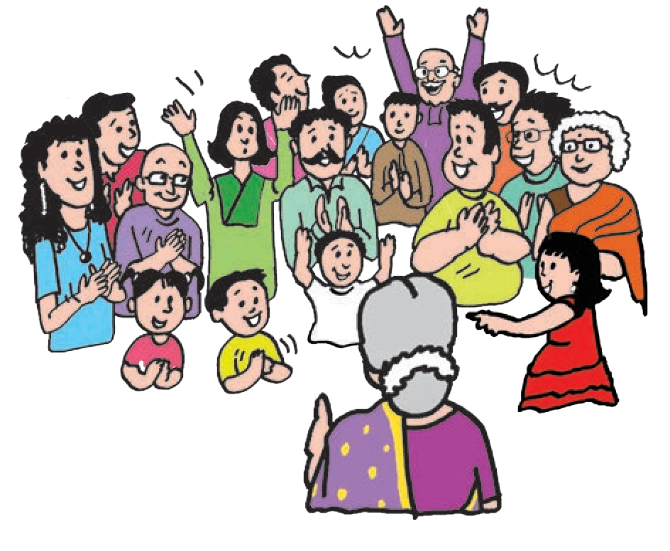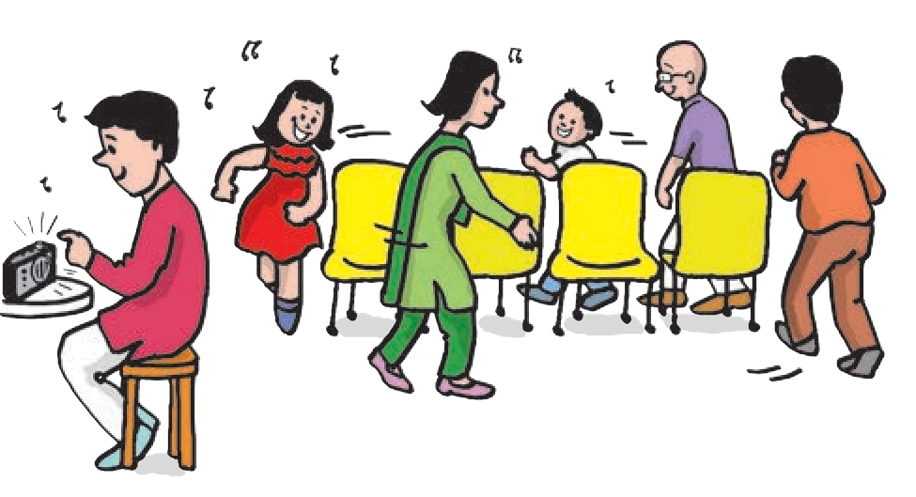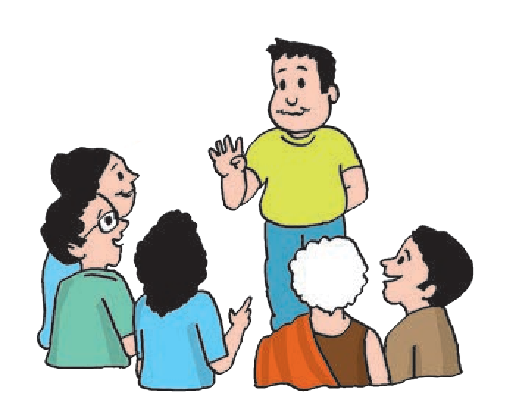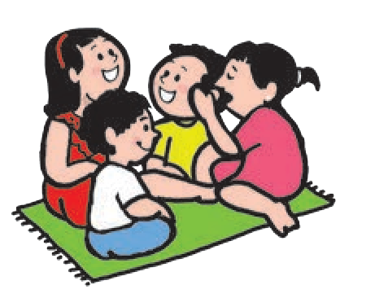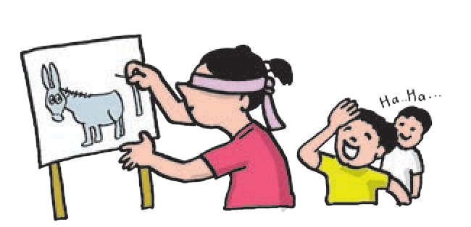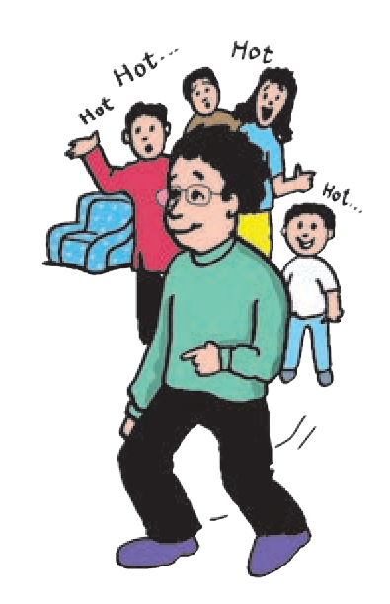

**Treasure Hunt**

* + You should not keep playing with some friends and ignore others.

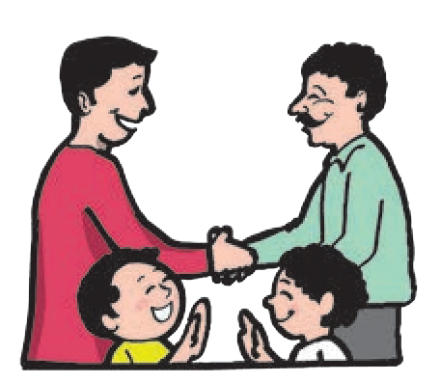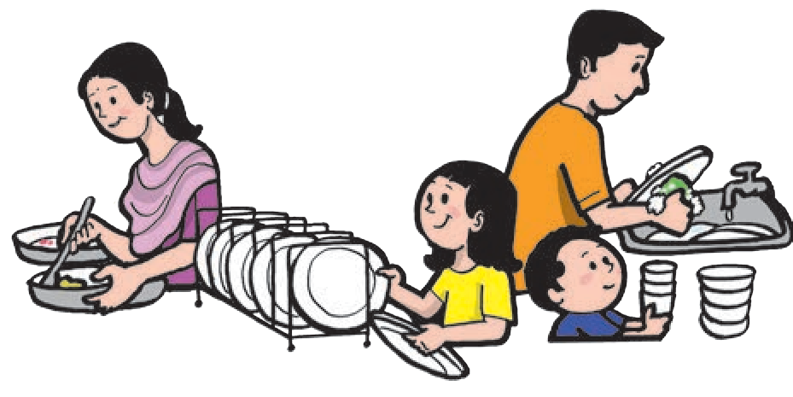

* When it is time for the guests to leave, you should say goodbye to each of them personally.
* Most important of all, help clean up after a party.

Unit 3

49

**If you are a guest, here are some tips for you :**

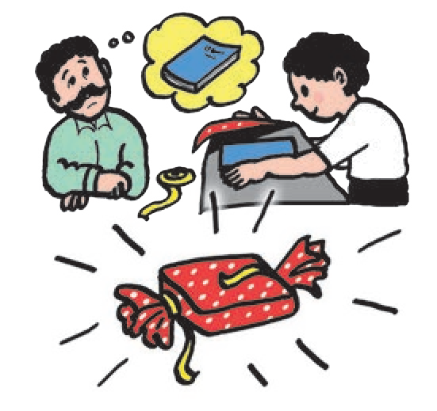

* + - Please acknowledge that you have received the invitation and let your host know whether or not you will attend the party.
    - If you are choosing a present for your host, think well about what he / she will like. A thoughtful gift is appreciated more than an expensive one.
    - Remember to remove the price tag or label from the gift. It is not polite to let your host know how much you have spent on the gift.
    - Wrap the gift well, and if possible, decorate the wrapping yourself.

**On the day of the party :**

* Be punctual. Reach in time for the party.
* If there is any work to be done, offer to help.
* Be friendly with the other guests.
* Take part in the programme and the games (if there are any) willingly.
* Appreciate the food and decorations honestly.
* Don’t waste food. Take only as much as you want.
* When it is time for you to leave, approach your host and say good- bye.

**The success of a party should be measured by the goodwill and friendship it creates. Be you a host or a guest, do all you can to boost it.**

Later on, let your host know - either personally or in writing - how much you enjoyed the party.

**Things to do :**

* **Group Work**
  1. Form groups of 5 - 8. Then make pairs of groups. Decide which group will be hosts and which will be guests. Arrange mock parties in the classroom so that the roles of hosts and guests can actually be played out.
  2. Later on, hold groupwise discussions on how your party went. Make lists of the tips you followed and those you forgot to follow.

Unit 3

50

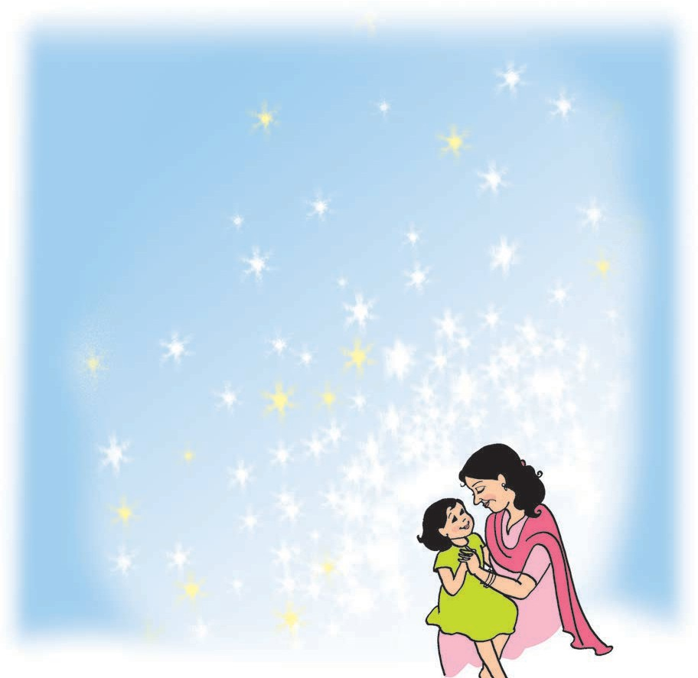

**20. Only One Mother**

Hundreds of stars in the pretty sky,

Hundreds of shells

on the shore together,

Hundreds of birds that go singing by,

Hundreds of lambs

in the sunny weather.

Hundreds of dewdrops to greet the dawn,

Hundreds of bees

in the purple clover,

Hundreds of butterflies on the lawn,

But only one mother the wide world over.

*- George Cooper*

**Things to do :**

1. **Make a list of the rhyming words in the poem.**

**Add one more rhyming word of your own to each pair.**

1. **Write some more expressions like ‘hundreds of ’. Expand each expression. Example**, ‘Hundreds of children in the school.’
2. **Answer the following questions.**



* 1. Why does the poet say that the dewdrops greet the dawn ?
  2. Do you agree with the poet’s thoughts ? Why ?

1. **Write a letter to any one of the following to tell them how much you appreciate them.**

* Your mother * Your father * Any one of your relatives * Your teacher

51

Unit 3

## The Journey to the Great Oz

*The Wizard of Oz is a well-known fantasy of children’s literature. It tells the story of Dorothy who is whisked with her dog Toto, by the cyclone to the wonderful land of Oz. There she meets the Tin Woodman who needs a heart, the Scarecrow who needs brains and the cowardly lion who needs bravery. They all want to see the Wizard of Oz, the only person who can help them. Here’s an account of a part of their journey to the Emerald City of Oz where the Wizard lives. Read the Wizard of Oz to find out what happens next.*

*The Wizard of Oz was written by Lyman Frank Baum (1856-1919). He has written many other books about Oz. This classic novel was also made into a movie.*

This was to be an eventful day for the travellers. They had hardly been walking an hour when they saw before them a great ditch that crossed the road and divided the forest as far as they could see on either side. It was a very wide ditch, and when they crept up to the edge and looked into it they could see it was also very deep, and there were many big, jagged rocks at the bottom. The sides were so steep that none of them could climb down, and for a moment it seemed that their journey must end.

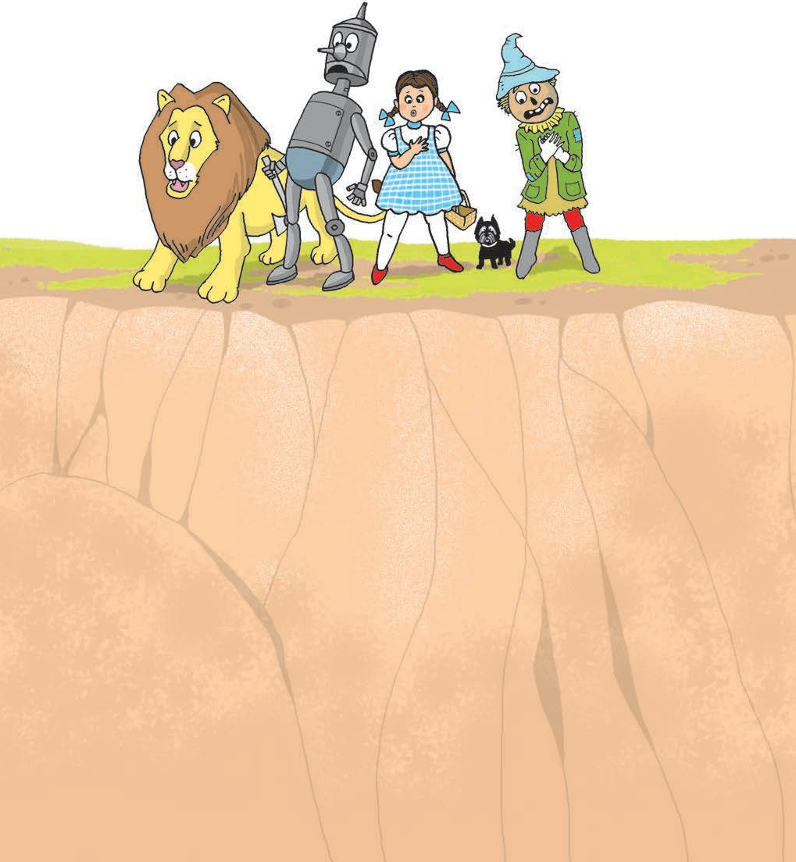

“What shall we do ?” asked Dorothy despairingly.

“I haven’t the faintest idea,” said

the Tin Woodman, and the Lion shook his shaggy mane and looked thoughtful.

But the Scarecrow said, “We cannot fly, that is certain. Neither can we climb down into this great ditch. Therefore, if we cannot jump over it, we must stop where we are.”

“I think I could jump over it,” said the Cowardly Lion, after measuring the distance carefully in his mind.

“Then we are all right,” answered the Scarecrow, “for you can carry us all over on your back, one at a time.”

“Well, I’ll try it,” said the Lion. “Who will go first ?”

52 Unit 3

“I will,” declared the Scarecrow, “for, if you found that you could not jump over the gulf, Dorothy would be killed, or the Tin Woodman badly dented on the rocks below. But if I am on your back it will not matter so much, for the fall would not hurt me at all.”

“I am terribly afraid of falling, myself,” said the Cowardly Lion, “but I suppose there is nothing to do but try it. So get on my back and we will make the attempt.”

The Scarecrow sat upon the Lion’s back, and the big beast walked to the edge of the gulf and crouched down.

“Why don’t you run and jump ?” asked the Scarecrow.

“Because that isn’t the way we Lions do these things,” he replied. Then giving a great spring, he shot through the air and landed safely on the other side. They were all greatly pleased to see how easily he did it, and after the Scarecrow had got down from his back the Lion sprang across the ditch again.

Dorothy thought she would go next; so she took Toto in her arms and climbed on the Lion’s back, holding tightly to his mane with one hand. The next moment it seemed as if she were flying through

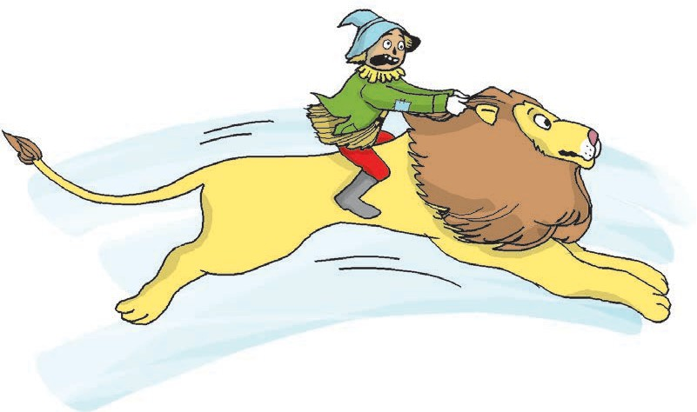

the air; and then, before she had time to think about it, she was safe on the other side. The Lion went back a third time and got the Tin Woodman, and then they all sat down for a few moments to give the beast a chance to rest, for his great leaps had made his breath short, and he panted like a big dog that has been running too long.

They found the forest very thick on this side, and it looked dark and gloomy. After the Lion had rested they started along the road of yellow brick, silently wondering, each in his own mind, if ever they would come to the end of the woods and reach the bright sunshine again. To add to their discomfort, they soon heard strange noises in the depths of the forest, and the Lion whispered to them that it was in this part of the country that the Kalidahs lived.

“What are the Kalidahs ?” asked the girl.

“They are monstrous beasts with bodies like bears and heads like tigers,” replied the Lion, “and with claws so long and sharp that they could tear me in two as easily as I could kill Toto. I’m terribly afraid of the Kalidahs.”

Unit 3 53

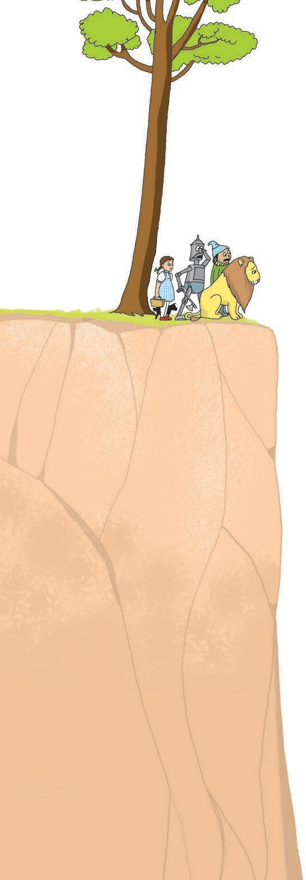

“I’m not surprised that you are,” returned Dorothy. “They must be dreadful beasts.”

The Lion was about to reply when suddenly they came to another gulf across the road. But this one was so broad and deep that the Lion knew at once he could not leap across it.

So they sat down to consider what they should do, and after serious thought the Scarecrow said:

“Here is a great tree, standing close to the ditch. If the Tin Woodman can chop it down, so that it will fall to the other side, we can walk across it easily.”

“That is a first-rate idea,” said the Lion. “One would almost suspect you had brains in your head, instead of straw.”

The Woodman set to work at once, and so sharp was his axe that the tree was soon chopped nearly

54

through. Then the Lion put his strong front legs against the tree and pushed with all his might, and slowly the big tree tipped and fell with a crash across the ditch, with its top branches on the other side.

They had just started to cross this queer bridge when a sharp growl made them all look up, and to their horror they saw running toward them two great beasts with bodies like bears and heads like tigers.

“They are the Kalidahs!” said the Cowardly Lion, beginning to tremble.

“Quick !” cried the Scarecrow. “Let us cross over.”

So Dorothy went first, holding Toto in her arms, the Tin Woodman followed, and the Scarecrow came next. The Lion, although he was certainly afraid, turned to face the Kalidahs, and then he gave so loud and terrible a roar that Dorothy screamed and the Scarecrow fell over backward, while even the fierce beasts stopped short and looked at him in surprise.

But, seeing they were bigger than the Lion, and remembering that there were two of them and only one of him, the Kalidahs again rushed forward, and the Lion crossed over the tree and turned to see what they would do next. Without stopping an instant the fierce beasts also began to cross the tree. And the Lion said to Dorothy:

“We are lost, for they will surely tear us to pieces with their sharp claws. But stand close behind me, and I will

Unit 3

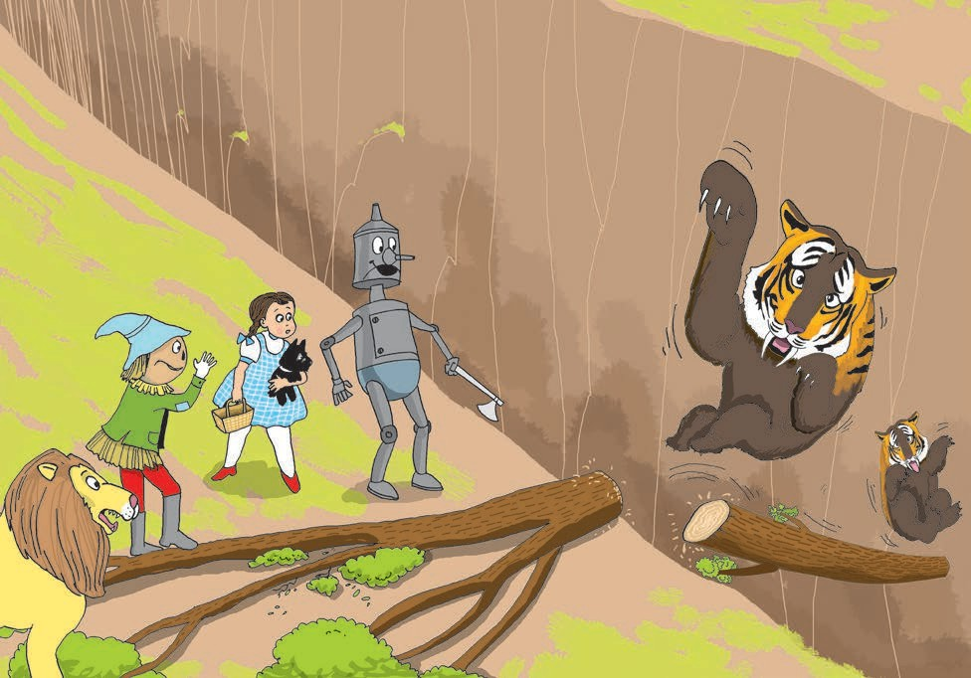

fight them as long as I am alive.”

“Wait a minute !” called the Scarecrow. He had been thinking what was best to be done, and now he asked the Woodman to chop away the end of the tree that rested on their side of the ditch. The Tin Woodman began to use his axe at once, and, just as the two Kalidahs were nearly across, the tree fell with a crash into the gulf, carrying the ugly, snarling brutes with it, and both were dashed to pieces on the sharp rocks at the bottom.

“Well,” said the Cowardly Lion, drawing a long breath of relief, “I see we are going to live a little while longer, and I am glad of it, for it must be a very uncomfortable thing not to be alive. Those creatures frightened me so badly that my heart is beating yet.”

“Ah,” said the Tin Woodman sadly, “I wish I had a heart to beat.”

This adventure made the travellers more anxious than ever to get out of the forest, and they walked so fast that Dorothy became tired, and had to ride on the Lion’s back. To their great joy the trees became thinner the farther they advanced, and in the afternoon they suddenly came upon a broad river, flowing swiftly just before them. On the other side of the water they could see the road of yellow brick running through a beautiful country, with green meadows dotted with bright flowers and all the road bordered with trees hanging full of delicious fruits. They were greatly pleased to see this delightful country before them.

- *From ‘The Wizard of Oz’ by L. Frank Baum*

**Things to do :**

1. **Read the words. Write other words which have the same ending.**

* eventful (- ful) * travellers (- ers) * despairingly ( - ly) * carefully (- fully)

1. **List the characters in the story and write a few lines about each of them.**
2. **Write in short how the travellers crossed the first ditch.**
3. **Write how the travellers crossed the second gulf.**
4. **Which events in the story tell us that -**

* the scarecrow was intelligent * the lion was brave.

1. **Activities**
   1. Imagine you are Dorothy and write about the day’s events in 5-8 lines in your (Dorothy’s) diary.
   2. Imagine you are the lion and someone is interviewing you. Write the answers to the following questions.
      * Who were your companions on the way to Oz ?
      * How did you take the others across the ditch ? Were you afraid ?
      * Were you afraid of the Kalidahs ? Why did you decide to fight with them ?
      * What did it feel like after you were out of the forest ?
2. **Language Study (See pages 84-88.)**
   1. Read the following aloud and note the highlighted words. They are

conjunctions.

“I am terribly afraid of falling, myself,” said the Cowardly Lion, “ but I suppose there is nothing to do but try it. So get on my back and we will make the attempt.”

The Scarecrow sat upon the Lion’s back, and the big beast walked to the edge of the gulf and crouched down.

“Why don’t you run and jump ?” asked the Scarecrow.

“ Because that isn’t the way we Lions do these things,” he replied. Then giving a great spring, he shot through the air and landed safely on the other side.

* * *

## A Book Review



**George’s Secret Key to the Universe**

George’s Dad is an ardent environmentalist. In fact, both his parents are convinced that modern inventions of science and technology have caused a lot of damage on the earth. They are committed to the cause of saving the planet. They use a bicycle instead of a car. There is a ban on TV and computers in their house. They don’t buy things like bread and biscuits. They eat only vegetarian and home cooked food. They even use candles to light the house to avoid using electricity. Poor George has to suffer a lot of jeering and ridicule from his friends because of all this.

Actually, George doesn’t think that either the TV or the computer is a bad thing. He has tried to tell his parents that it’s possible to save the earth using the computers and the internet. But no ! In their house, there can’t be ANY discussion on that issue. George always likes to know ‘why’. But who is to answer his questions ? His parents think that he is still too young to understand global issues.

One day, however, George unexpectedly acquires a new friend and next door neighbour - Annie. Annie’s father Eric is a brilliant scientist and ever willing to answer all of George’s questions. Eric has built a super super intelligent computer named Cosmos. Cosmos has incredible powers. It can literally open windows on the universe and take you to any planet, star, comet and even to a black hole ! And of course Cosmos can also bring you back from there. However, Cosmos depends entirely on the information that is fed into it by people

like Eric who do the research and thinking that can make Cosmos work.

Science can be used for a good cause and a group of good scientists like Eric have vowed to use it for people’s welfare. Unfortunately, there is one odd angry scientist who wants to use science for his own selfish motives. He is planning to steal Cosmos and all of Eric’s research so that he can establish his own rule on another planet. It so happens that only George can do something to overcome the wicked plans of the nasty scientist. If you want to know what adventures he undertakes and what strategies he has to use to stop the power hungry scientist, you have to read the novel, ‘George’s Secret Key to the Universe’.

The author of this wonderful adventure is Lucy Hawking. The story of the novel is imaginary but it also includes plenty of charts, photographs, boxes that give you hard facts about our solar system, galaxies, space and the whole universe. This information

has been presented in a very simple, easy to understand manner by none other than Stephen Hawking, who is said to be one of the greatest scientists of our times. His achievements are all the more astounding as he is a victim of many physical ailments. He has to use a wheelchair to move about and uses a computerised voice system in order to ‘speak’. The story of Stephen Hawking’s triumph over his physical disabilities is itself an inspiring adventure.

The book includes very attractive and expressive sketches drawn by Garry Parsons.

It is true that the excessive use of science and technology can give rise to certain problems. But turning away from technology is not the solution. That is why the Hawkings have given an important message in this book

- More research, more studies and a commitment to use them not for selfish gains but for the welfare of the entire living world !

**Things to do :**

* **Activity**

Write a short book review of any one of your favourite books. Your review should include the following things.

* + Title of the book
  + Name of the author / authors
  + Name of the illustrator (artist)
  + The central idea of the book (what the book is about)
  + The important characters in the book and what they do
  + What you like about the book
  + Why you want others to read the book / what you learn from the book

### Write your own Poem

* 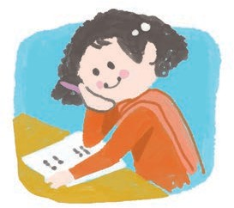Write a set of rhyming words. Make sentences or meaningful phrases in which the rhyming words appear at the end. Arrange the sentences or phrases in the form of a poem.
* 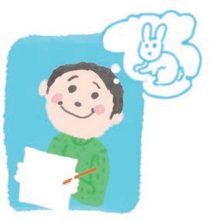Think of something that you like very much. Describe it in as much detail as you can, stressing the part you like best. Make use of suitable adjectives, adverbs or comparisons. Arrange the lines one below the other in the form of a poem.
  + 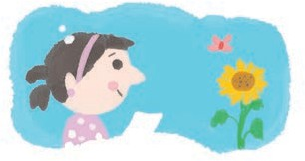Observe things in your surroundings carefully. Write short but good descriptions of what you see, hear, smell, feel, etc. Arrange your observations in short lines written one below the other, in the form of a poem.
  + How do you feel when you are very happy or very angry or very sad ? What do you say to yourself on these occasions ? Try to write it down and arrange it in the form of a poem.

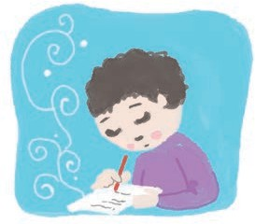Why......

How could I......

Never will I.....

Some ideas are suggested here to encourage and motivate the students to write poetry. The teacher should discuss each idea in the class and try to develop a poem through a collective effort. Then, children should be given enough time in the classroom itself to write their own poem. This exercise can be repeated at regular intervals for some time. Encourage the children to write poems at home, too.

## Senses Alert

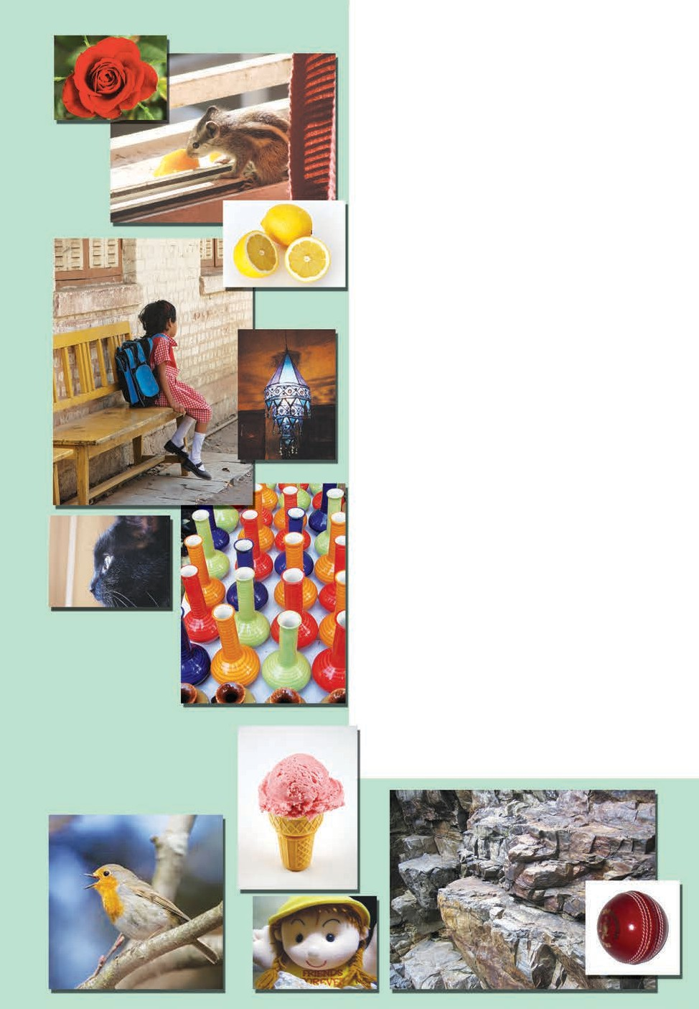

#### Look at the photographs on pages 60-61 carefully and imagine the following :

* The colours, shape, size, actions, etc. of what you see in the picture.
* The sound / sounds you may hear at the scene of the photograph.
* How the different things, birds, animals, etc. in the picture feel to the touch.
* The smell / smells you may smell at the scene of the picture.
* The taste of what you see in the picture.

**In short, let your imagination include all your five senses.**

**Now, write short descriptions of any 8-10 of your choice.**

**Remember to make use of your senses (one or more !) when you describe a photograph. You will find the following words and phrases useful. You may also use other words you know.**

The photograph shows a tiny, black kitten. It is looking at something

carefully. It is very soft. It is not making any noise.

* + **What you see can be :**

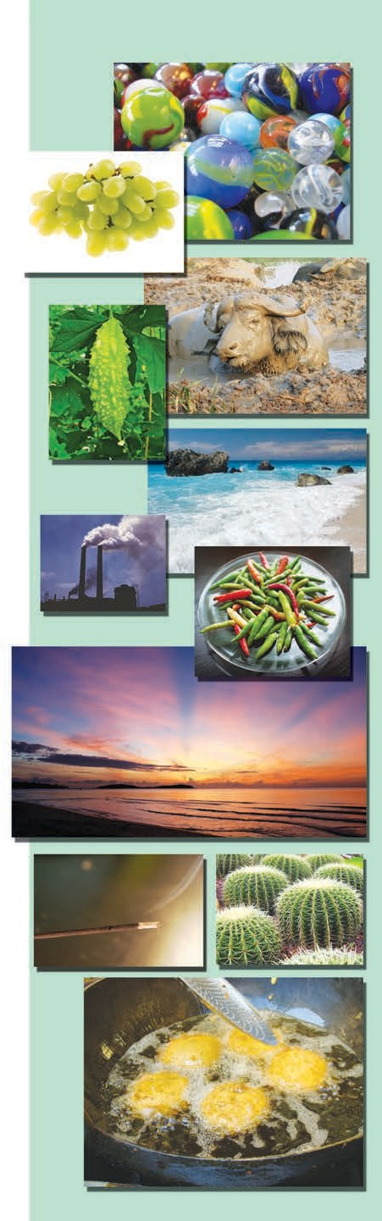

* big, small, tiny, huge, bright, dim, faint, dark, black, white, orange, green, blue, red, yellow, ... round, square, rectangular, zigzag, straight, crooked, ..., colourful, beautiful, lovely, wonderful, etc.
* It could be sitting, waiting, walking, going, flying, swinging, shining, etc.

#### The sound / sounds may be :

* sweet, loud, soft, harsh, shrill, etc.
* The sound can be a screech, a crash, a honk, a whisper, a sigh, a scream, a noise, etc.

#### To the touch things can be :

* hot, cold, warm, cool, soft, hard, smooth, firm, rough, wet, dry, sticky, slimy, etc.

#### Things may smell :

* nice, sweet, good, bad, foul, etc.
* It could be a strong / fresh / delicious

/ pleasant smell.

* The smell can be a scent, an aroma (a good smell), a fragrance (a good smell), an odour, a stink (a foul smell), etc.

#### Things may taste :

* sweet, sour, bitter, salty, nice, etc.
* you could call things cool, juicy, crunchy, yummy, tasty, etc.

The photograph shows an incense stick burning.

The smoke is white and curling. The sweet fragrance of Champa flowers spreads. It makes me happy.

* * *

Unit 3 61

## The Man in the Moon

**Unit Four**

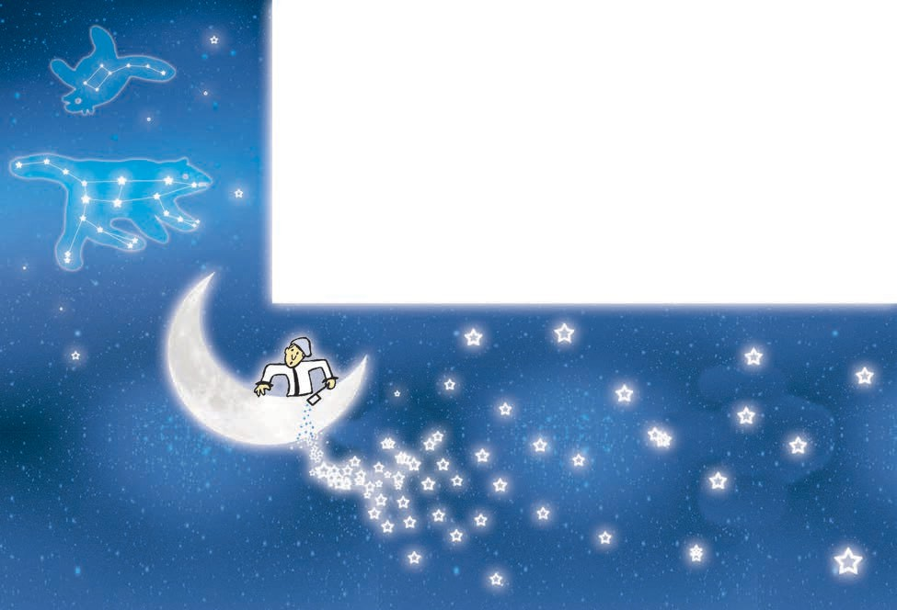

The Man in the Moon as he sails the sky Is a very remarkable skipper.

But he made a mistake when he tried to take A drink of milk from the Dipper.

He dipped right out of the Milky Way, And slowly and carefully filled it,

The Big Bear growled, and the Little Bear howled And frightened him so that he spilled it !

**Things to do :**

1. **Read the following.**
   * Skipper : captain of a ship or boat. * Dipper : This word has two meanings. Dipper means a container for taking out water. Also, there are two constellations called Little Dipper (Little Bear) and Big Dipper (Big Bear) in the sky.
   * Milky Way : The band of light consisting of stars that spreads across the sky at night.
2. **Answer the following questions.**
3. What mistake did the man in the moon make ?
4. What did he try to take the milk from ?
5. Why did he spill the milk ?
6. **Read the following and say whether the statements tell you about facts or whether they are imaginary.**
   * There is a man in the Moon. * The Moon sails across the sky.
   * The milky way contains milk. * You can fill the Dipper in the sky with milk.
   * The Big Bear in the sky can growl. * There are a number of stars in the sky.

## Water in the Well



What a farmer needs most for his fields is a good source of water. Kasim had his eye on a well that was just outside the boundary of his field. But Ahmad, the man who owned the well, was a crafty old man. He wouldn’t allow anyone to draw water from his well. He told Kasim, “Why do you come to me again and again to beg for access to my well ? I feel sorry to turn down your request every time. I have a suggestion for you. Collect some money and buy the whole well from me.”

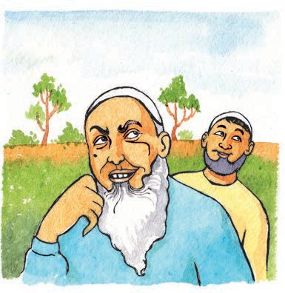

Kasim thought over the suggestion and liked it. He knew Ahmad would ask for a lot of money but he saw in his mind’s eye, channels of water running from the well through his field and made a decision. He took all his savings to Ahmad and bought the well.

The next day, he went to the well happily and dug out a channel. But when he began to draw water, there was

a surprise in store for him. Suddenly Ahmad

came forward and announced, “What are you doing, Kasim? How dare you touch the water in my presence ?”

“What do you mean - haven’t you sold this well to me ?”

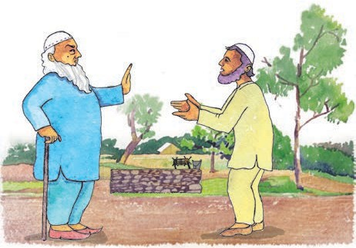

“Ah, I sold the well all right, but not the water in the well. The water still belongs to me. You can’t use it. If you needed the water along with the well, you should have said so. I have a suggestion for you. Pay for the water separately and use it. You can buy fresh water every day. I don’t mind !”

Kasim was shocked to hear Ahmad’s argument. It was so unfair, so unjust ! He rushed to the Qazi and told him the whole story. The Qazi was a wise man. He told Kasim to bring Ahmad to his court so that he could hear both sides of the case.

Ahmad was summoned to the court. The Qazi heard his argument patiently.

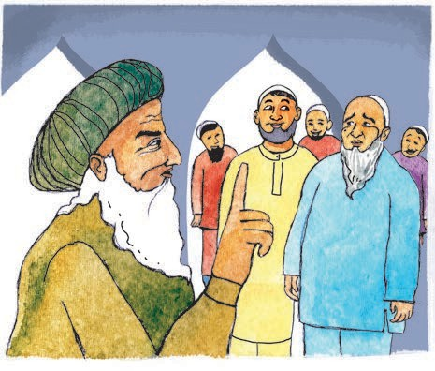

“Hmm, I see that you are right. What you have sold is the well, the water is all yours. Isn’t that so ?’’

Kasim’s heart sank, when he heard the Qazi’s words. Ahmad in his heart of hearts was overjoyed. He had never thought the Qazi would side with him.

“My Lord, I am so grateful you understand the fine points of this case. The water does indeed belong to me.”

“In that case, Ahmad, why are you keeping it in Kasim’s well? You have no right to keep your belongings in his property. You must remove them immediately. Or else, you can pay a daily rent to Kasim. Then he will allow you to use his well.”

Ahmad was so confused that he did not know what to say. All the people present in the court began to laugh.

But Kasim was a generous man. He never troubled Ahmad for the ‘rent’ that was due from him.

* * *

**Things to do :**

1. **Find a word that has a similar meaning.**

* sorry * whole * happily * unfair * remove

1. **Answer the following questions.**
   1. What does a farmer need most for his fields ?
   2. Where was the well situated ?
   3. What did Ahmad tell Kasim when he dug a channel and began to draw water ?
   4. What did the Judge tell Ahmad ?
   5. How do we come to know that Kasim was a generous man ?
2. **Find the meaning of the following phrases and use them in your own sentences.**

* again and again * thought over * in his mind’s eye * in store for ....

* (his/her) heart sank * heart of hearts

1. **Group Work**

Form groups of 5-8. In each group, rewrite the story in the form of a play. Present scenes from your play in the classroom.

## The Legend of Marathon



*The ‘marathon’ is a sporting event. It is a running race of about 42 kilometres. The word ‘marathon’ also means ‘a task or event that lasts a long time and requires a lot of effort and patience’.*

*The first marathon race was organized at the time of the first Olympic Games which were held in Greece. The marathon was started in the memory of a legendary Greek hero, Pheidippides, who had carried an important message from the battle of Marathon to Athens. Given below is the story of his famous run from Marathon to Athens. We do not know whether the story is historically accurate, but it has inspired many generations of sportsmen.*

About two thousand and five hundred years ago, Persia was a mighty kingdom. Their large army had landed in the bay near the town of Marathon. Their target was Athens, a city state in Greece. Athens had a small army compared to the Persian one. But the Athenian soldiers were very brave. They had faced the Persians before, but they needed help from other Greek kingdoms now. They decided to send a special messenger to the neighbouring kingdom of Sparta. His name was Pheidippides.

Pheidippides was a young man who served as a ‘day-long runner’. He ran to Sparta like the wind. He covered the distance of nearly a hundred kilometres

in a day. But alas! The people of Sparta were busy with some ceremonies. They did not want to join the battle immediately. Pheidippides took this message back to Athens with a heavy heart, but on light feet. Again, he ran a hundred kilometres within a day.

When the Generals of Athens heard the cold Spartan response, they did not lose heart. They were ready to fight on their own. The Persian army was watching Athens like a cat watches a mousehole. So, they decided to launch a surprise attack on the Persians. The Athenian Generals sent their flanks round the Persian forces like speeding arrows and began to draw them in. The Persians were not ready for battle.

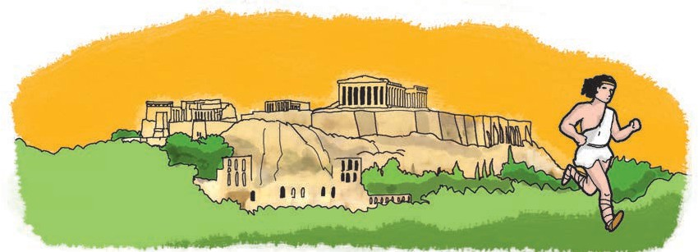



Even so, they were skilled archers. They showered arrows on the soldiers of Athens. But the arrows simply fell off their helmets and strong armours. Also, the Athenians knew their seashore well. The Persians were new to the terrain. Many of them were killed. Many more were injured. Some of them were lost in the marshy areas. The brave Athenians drove back every single remaining Persian soldier back to their ships anchored in the bay. The battle was over within a few hours.

The battle was over but the Persians did not accept defeat. They saw that the entire army of Athens had rushed to the seashore, leaving the city of Athens far behind. Only the aged people, women and children were left in the city. The Persians now devised a new plan. The sea-route to the city of Athens was much shorter than the land route. The Persians decided to take the sea-route and pounce upon Athens from the seaside. The

Athenian army would take very long to travel back to Athens on foot, with their heavy armour and weapons. Seeing the Persians, the defenceless people in the city of Athens would think that Athens had lost the battle. Then it would be easy for the Persians to take over the city.

The Athenian Generals too, were good strategists. When they saw the Persian fleet leave in a hurry, they understood the Persian plan. They resolved to go back to Athens as fast as possible to defend it. But, it was very necessary to let the people of Athens know that they had won. Then they would not open the city gates to the Persians. They would wait for the victorious Athenian army to return. The city would be safe. Who would take this message to them? The message must be delivered before the Persians reached there. Who would travel faster than the Persian ships and that too, on a longer route? Who else but Pheidippides !

Pheidippides had already completed a run of more than two hundred kilometres just the day before. But he was a brave young man. He would do anything for his State. Also, this time he was to carry a happy message.

It was not easy for Pheidippides to reach Athens sooner than the Persians did. That is why, this time, he left the usual safe route and chose another one that passed through cliffs and mountains but was much shorter.

Pheidippides scaled the first steep cliff and picked up speed. He had to run more than forty kilometres. It was very hot. He began to perspire. There were some shady olive trees on one side of the road. But Pheidippides couldn’t wait, couldn’t rest. He just ran on and on. His heart began to beat faster, he became weak with hunger and thirst, but he didn’t stop.

At last, Pheidippides came within sight of the city-gates of Athens! He

was successful in his mission. He had reached before the Persians.

The people of Athens threw open the gates to Pheidippides.

“What happened, Pheidippides? Do you bring good news or. ?”

“Yes ! Yes ! Joy to you ! We won ! We won ! ” As soon as Pheidippides had delivered this message, he collapsed - never to rise again. He had laid down his life in the service of Athens.

The story of Pheidippides has inspired the people of Greece for many centuries. His historic run from Marathon to Athens became a legend.

When the Olympic Games were started in Greece, this legendary event was commemorated in it in the form of the sporting event, the marathon. Today, marathons are arranged in many countries. When you see one, or when you are old enough to take part in one, remember the first marathon runner.

**Things to do :**

1. **Show the major events in the story of Pheidippides on a ‘time-line’.**
2. **Activities**
   1. Prepare and present a short speech on the following.
      * An inspiring incident in the life of a great leader.
      * How I accomplished a difficult task.
   2. Write a short essay on the following.
      * My favourite sports event.
      * What I would like to do for my country.

***

## All about Money

We all need money to buy things

and to pay people who work for us.

But what is ‘money’ ? Who invented ‘money’ ?

Today, we see money in the form of coins and notes.

Currency : Cash Money

coins notes

a fifty-paise

coin

a five-rupee note

a ten-rupee

note

a

one-rupee coin

a five-rupee

coin

twenty rupees

a hundred-rupee note

fifty rupees

five hundred rupees

a

ten-rupee coin

a two thousand- rupee note

`



These are the coins and notes we use in India.

But different countries use different coins and notes. Their money is known by different names.

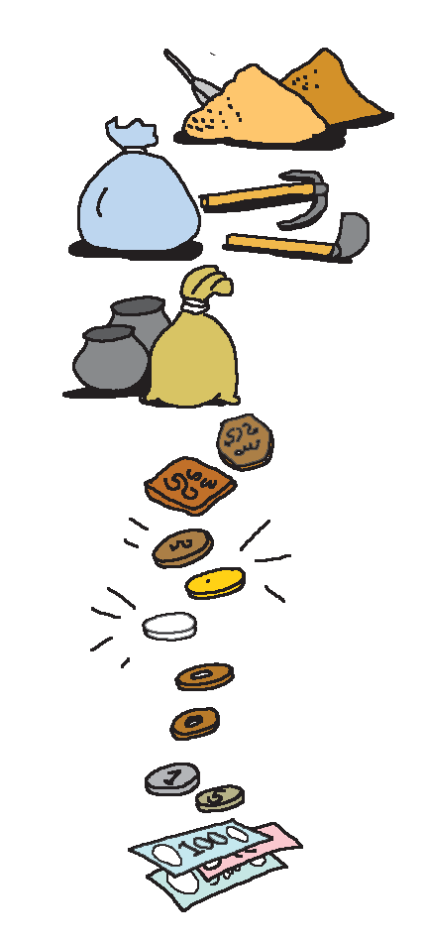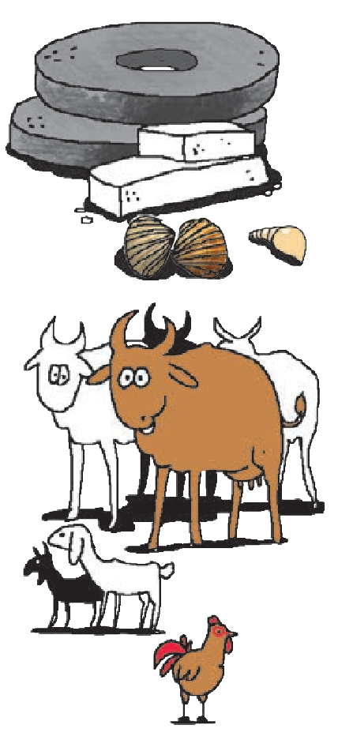

In the United States, they use $ dollars. In England, they use £ pounds.

But long, long ago, people did not use coins and notes. They exchanged one thing for another.

This was known as ‘barter’.

It may seem unbelievable, but long ago people even used special stones as money !

Imagine how difficult it must have been to carry this money !

People also used bricks of salt, shells and cowries as money in the past.

They gave grain, farm produce, cattle, goats, chickens, etc. in return for things like clothes, tools and implements or as wages.

Then they began to use bits of precious metals like gold, silver and copper as money.

It was easier to carry this money around.

Paper money was first used in China about 1000 years ago.

Paper money or notes have no value

of their own, but a note is a ‘promise’ to give that much money.

These notes are printed by the government. No one else is allowed to print notes.

You must use your money carefully.

You should not write on the notes or tear or crumple the notes, or damage them in any way.

You should also be careful when you spend money. People have to work hard to earn money !

***

**Things to do :**

1. **Write a short note on ‘money’.**
2. **Look at the diagram on page 68. It is called a tree diagram because it has ‘branches’. Now read the following and draw a tree diagram to show this information.**

Things in our surroundings form two groups - living things and non-living things. Living things are of two kinds, plants and animals. There are two types of plants - flowering plants and non-flowering plants. If we consider animals, we see that some animals lay eggs. They are oviparous animals. Some animals give birth to their young ones. They are viviparous animals.

Find more topics from your Environmental Studies or Mathematics textbooks for drawing tree diagrams. Draw and label the diagrams.

1. **Make meaningful sentences from the following table.**

|  |  |  |
| --- | --- | --- |
| * She was tired * She wanted to buy a car * He was angry * He did not know the answer * They did not have money * He did not read the book | but | * she finished her homework. * she had no money. * he did not fight. * he did not copy his friend’s answer. * they lived happily. * he knew the story. |

Now try joining the sentences in the two columns using (1) and, (2) because.

1. **Ask your parents or other grown ups to show you some used notes. Observe them carefully. Have they been used properly ? Write your observations.**
2. **Write an autobiography of a hundred-rupee note. (8-10 lines.)**

**\*\*\***

## 29. A Lark

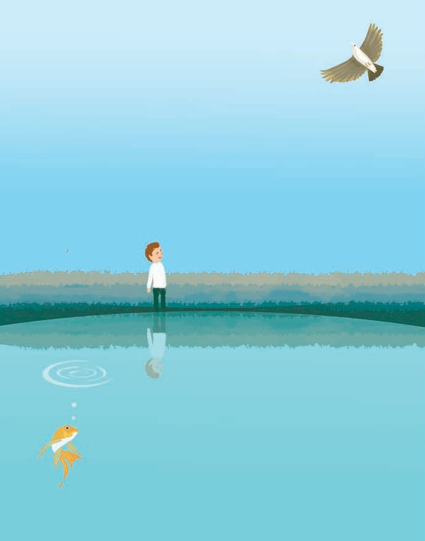

Lark-bird, lark-bird, soaring high, Are you never weary ?

When you reach the empty sky Are the clouds not dreary ?

Don’t you sometimes long to be A silent goldfish in the sea ?

Goldfish, goldfish, diving deep, Are you never sad, say ?

When you feel the cold waves creep Are you really glad, say ?

Don’t you sometimes long to sing And be a lark-bird on the wing ?

*- Lawrence Alma-Tadema*

**Things to do :**

* 1. **Guess the meaning of -**

* weary * dreary * on the wing.

* 1. **Answer the following questions.**
     1. Write what the lark does.
     2. Write what the goldfish does.
     3. What does the poet want to know from the lark ?
     4. What does the poet want to know from the goldfish ?
  2. **Recite the poem.**
  3. **Do you long to be something else ? Write about your longing.**

## Be a Netizen

Have you seen or used a computer ? Computers have brought about many changes in the way we do things. One of the most amazing features of the computer world is the Internet or the Net.



A network is a system of tubes, wires, roads, etc. which are all connected to each other. The internet or the net is a network of computers. It links thousands of computers or smaller networks of computers with one another. It is so large that millions of people around the world can use it at the same time.

The internet makes it possible for computer users to get or send information very quickly. All you have to do is to log on, that is, give instructions to your computer to start using the internet. Then you may see on the net, all the information you need. The information may be in the form of text, pictures, moving images, or even sounds, speeches or music. You can also send your own information on the net.

Once you have gathered or given the information on the internet, you can log off, that is, give instructions to your computer to get disconnected from the net.

The internet is like an ocean of information. You may wonder how one can find tiny bits of information in this ocean, but it is not at all difficult.

72

The information on the net is stored and made available in a systematic way on websites. Websites are places on the net. Each website has its own address. Using this address, you can visit a website, that is, you can read or view the information stored on it. The thousands of websites on the net together form the World Wide Web (WWW).

There are special computer programs known as search engines which help you to find the different websites on the World Wide Web. If you type the word or subject on which you want information, the search engine shows on your screen, a list of websites that have the information. You can then go to that website. Looking at the various websites is known as browsing or surfing the net.

A website is like a book or magazine, but you cannot make changes in a book once it is printed. It is possible to change the text or pictures on a website as many times as you like. So, makers of the website can ‘update’ a website.

Unit 4

While your computer is connected to the internet, you are ‘online’. You can do many things online like reading, watching a movie, listening to songs or even chatting and playing computer games with other people who are ‘online’ in any part of the world at that time. When you are not connected to the net, you are ‘offline’.





Sometimes, you gather a lot of information on the net which you want to read or use later. What do you do, then ? You can make a ‘copy’ of the text or pictures or movies on your computer and store it there. In other words, you download the information on your computer and then use it any time you like.

To send information on the net, you first need to get it ready on your computer in the way you want it on the net. You need a website to display the information on the net.

You can also get your own personal address on the net. You can receive messages on this address and also send them. This system of sending and receiving messages or mail on computers is known as e-mail or electronic mail.

An e-mail address is short and unique. No two e-mail addresses are the same. With the address, you get an account on the net. Your account is like your own letter box on the net. The only difference is that you can use this letter box not only for receiving mail but also for sending it. When you grow up, you can get your own e-mail account.

You can lock this ‘letter box’ by using a password. A password is a secret word or group of letters and / or numbers. The computer will allow a person to use or see the account only when the person types the correct password !

People who live in a city are citizens. People who use the net are netizens. Would you like to be a netizen ?

**Things to do :**

1. **List the words or phrases related with computer or the Internet.**
2. **Answer the following questions in one sentence each.**
   1. Have you ever seen or used a computer ?
   2. What is the ‘Internet’ ?
   3. What is a website ?
   4. What is the world wide web ?
   5. What are search engines ?
   6. What is meant by browsing or surfing ?
   7. What is meant by being ‘online’ ?
   8. What is meant by being ‘offline’ ?
   9. What is ‘e-mail’ or electronic mail ?
   10. What is a password ?
   11. Who is a ‘netizen’ ?
   12. Would you like to be a netizen ?
3. **Draw a diagram to explain the idea of Internet.**
4. **Find a picture of a computer with the help of your teacher and label the different parts you see.**

**For example,** monitor, screen, speakers, processor, mouse, mousepad, keyboard, etc.

1. **List all the pairs of antonyms you find in the passage.**
2. **WWW is a short form of** World Wide Web.

Find ten other short forms related to ICT (Information and Communication Technology).

1. **Choose a word that has at least four letters in it.**

**Imagine that it is a short form. Write the name / phrase / words it stands for. For example,** STEP : Sunday and Thursday Evening Programmes.

**\* * \***

## Give your Mind a Workout !

The proverb ‘A sound mind in a sound body’ simply means that one’s body and mind should both be kept fit and healthy. We need a healthy diet and proper exercise to keep our body fit. What do we do to exercise our mind ? The answer is quite simple. Just as we ‘work out’ or play games for physical exercise, we can use puzzles, riddles, board games, jokes, etc. to exercise our mind. Let us look at some interesting examples of games, puzzles, riddles and fun facts.

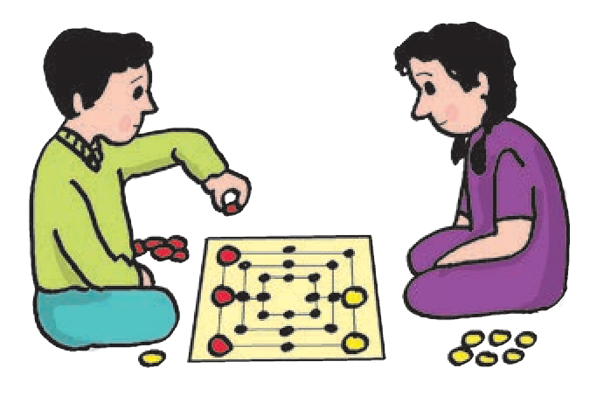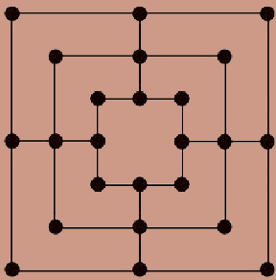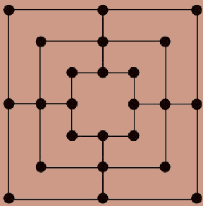

#### Nine Men’s Morris

This game is played with two players. Each player has nine pieces, one set black, one set white. You may simply draw the board as shown alongside and use buttons, beads, seeds, etc. as pieces. The players take turns to place their pieces (men) in the empty spots, one at a time. If you are able to place three ‘men’ in

a row or column, you form a ‘mill’. Then you can remove one of your opponent’s men. You cannot remove men in your opponent’s mill, unless he/she has no other men left on the board.

Once you have placed all your men on the board, you can start moving them only to an adjacent empty spot.

If you have only three men left, they can ‘fly’, that is, they can move to any vacant spot on the board.

Mill

If a player has less than three men left, or is unable to make a move, he / she loses the game !

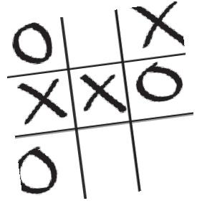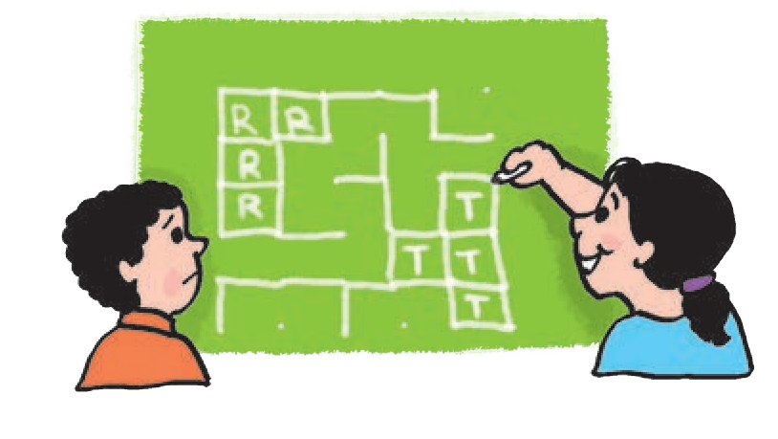

Find out how to play other simpler games like ‘tic-tac-toe’, ‘dots and boxes’, etc. and also other board games. You can also invent your own board games.

Unit 4

75

#### A Mathemagic Trick :

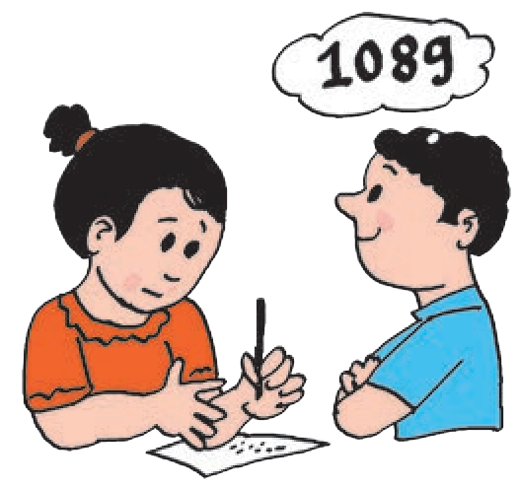

Take any three-digit number in which the first and the last digits differ by two or more. For example, 145.

Write the number in reverse order, which is 541.

Now subtract the smaller of the two numbers from the bigger one. (541-145)

The difference is 396.

Now reverse this number, you get 693.

Add these two numbers. The result is 1089.

No matter which three-digit number you start with, the result is always 1089 !

Try this trick with your friends or family members and surprise them by telling the answer yourself !

Find other tricks with numbers with the help of your parents, teachers or from the internet !

#### A Puzzle :

Pintu invited ten of his friends for a birthday party. He had 10 pencils in a box. He gave each of his friends 1 pencil as a gift. After that, there was one pencil in the box. How did that happen ? Explain.

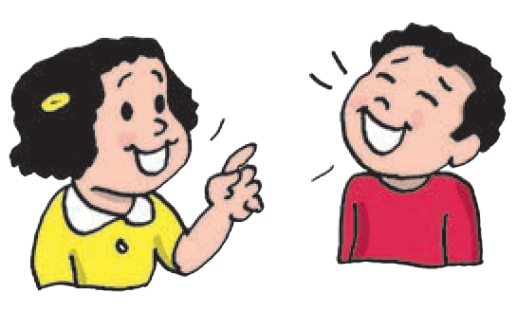

Find more such puzzles / riddles from other books, magazines or from the internet.

#### Jokes :

**Teacher :** Neena Aunty gave you and your younger sister a guava and asked you to share it equally. How much of the guava will you get ?

**Ananya :** All of it ! My younger sister doesn’t like guavas.

**Teacher :** Saurav, tell me, who makes changes in his environment ?

**Saurav :** Sorry, Madam, but I didn’t do anything !

Find other jokes related to your school subject from sources like magazines, books or the internet.

## Helen Keller



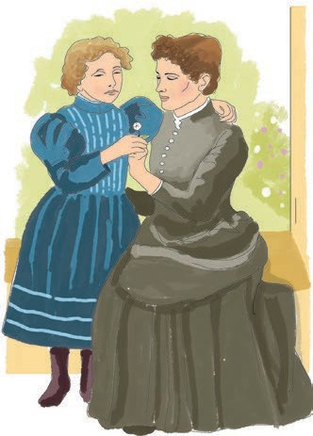This is the story of o child who become completely deof ond blind before she hod leornt to tolk. Because of her own couroge

ond olso thot of her wonderful teocher she leorned to tolk ond write. She wos oble to go to school ond to college ond to live o full ond hoppy life.

Helen wos born in 1880 in o smoll town in the southern U.S.A. At 18 months, when she wos beginning

to tolk, she suddenly become terribly ill ond very neorly died. When she recovered she wos completely deof ond blind.

It is very difficult for o deof child to leorn to tolk. Most bobies leorn by heoring other people tolking. But the deof child connot heor onyone so how con she know whot tolking sounds like? Mony deof people leorn to lip- reod, ond they become very clever ot understonding whot other people ore soying by wotching them. But Helen could not see whot other people were doing. She remembered o few words she hod known before she wos ill, for instonce, she went on colling woter ‘woo-woo’. But she hod to moke signs for most things. She would shoke her heod for ‘No’, ond nod for ‘Yes’. A

pull meont ‘Come’, ond o push, ‘Go’. But of course she could soy very little like this, ond she depended entirely on other people. Yet Helen hod on octive mind ond o clever broin, ond wonted to do ond soy everything ony other child would. She used to get into terrible tempers when she could not exploin whot she meont, or understond whot others wonted.

Then when Helen wos neorly seven, Anne Sullivan come to teoch her ond look ofter her. This clever ond devoted teocher chonged Helen's life.

Anne Sullivon herself hod been neorly blind ond hod been ot o school for blind people. There, Anne Sullivon hod leornt the fingerspelling method. She felt sure thot this wos the only woy to tolk to Helen ond teoch her to soy whot she wonted. Becouse Helen could not see her moking the signs, she would spell the words onto her pupil's hond. Helen hod become very sensitive to the feel of things, much more sensitive thon most people ore. She could soon tell the difference between the feel of one letter ond onother.

Unit 4 77

Miss Sullivan gave Helen a doll, and when she gave it she spelled the letters D-O-L-L onto Helen’s hand. She did this with the names of other things, such as C-A-K-E, and M-U-G. Helen obediently spelled them back; but she did not understand what it all meant, and she soon grew bored and unhappy. She would not try any more, and poor Anne Sullivan did not know what to do next.

Then one day Miss Sullivan took Helen outside to the water pump. As the water spilled into Helen’s mug and overflowed on her hand, Miss Sullivan spelled W-A-T-E-R on her other hand. Suddenly Helen’s face lit up. She understood that W-A-T-E-R was the name of this cold wet stuff, and it came to her in a flash that everything has a name.

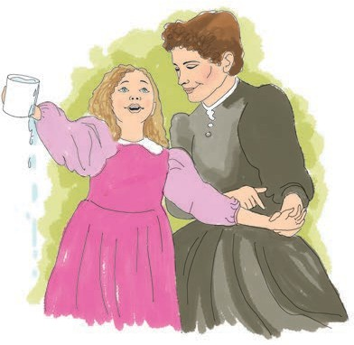

Touching her little sister, she spelled B-A-B-Y, which was one of the words Miss Sullivan had shown her. All that day and for days after, Helen darted from one thing to the next demanding that Miss Sullivan should spell their names for her. She became so excited she could hardly

control herself. At last words began to have a meaning for her. She then learned the names of actions as well as things; SIT, STAND, RUN, WALK;

and then descriptions of things and actions HARD, SOFT, QUICKLY,

SLOWLY. From then on she was able to learn as any child does. Only, Helen spelled words with her fingers instead of saying them aloud. Although she made noises, she still could not talk.

Now that she had started to learn, Helen, with her quick brain and good memory, learned very fast indeed. She learned to spell words incredibly fast, and soon she and her beloved teacher could have long conversations. Wherever they went, Miss Sullivan described things to her and told her what people were saying. Helen soon learned to write on a special frame with ridges to keep the lines straight, and, later she learned to type. She began to read Braille books.

The next thing was to learn to talk aloud. For this she had a special teacher who taught her how to move her lips and tongue. Helen quickly learned to talk also and to ‘listen’ to people speaking by putting her sensitive fingers on their lips and throats. This meant that she could talk with people who did not know the fingerspelling method, so long as they spoke distinctly. All this was hard work, needing endless patience by both pupil and teacher, and long practice.

In time she could talk, read and write, and even learnt to speak

French and German. Now Helen was determined to go to university and take a degree. When she was twenty, she sat for the entrance examination of Radcliffe College, one of the best colleges in America. The papers were set in Braille, and she typed her answers. Of course, she could not read what she had written. She had to take a chance that she had made no mistakes. She had no difficulty in passing the examination and entering Radcliffe.

Miss Sullivan was with Helen all through her time at the university. In the end, this girl, who at seven had lived in a dark world, unable to hear, or speak, won high university honours.

Throughout her life, she helped other blind people to find courage. She travelled all over the world inspiring everyone by her example.

Helen Keller lived to a ripe old age of eighty-eight. She passed away in 1968.

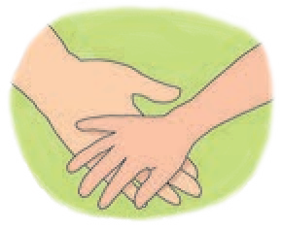

**Things to do :**

1. **Answer the following questions.**
   1. How did Helen overcome her handicaps ?
   2. What part did Anne Sullivan play in Helen’s life ?
   3. How did Helen Keller help other blind people ?
   4. Helen Keller’s life is the story of......
      1. a blind woman.
      2. courage, patience and struggle.
      3. a helpless, unfortunate girl.
2. **Activity**
   1. What is meant by ‘Honour the white cane’?
   2. Find out what ‘Braille’ is.
   3. Find out the difference between fingerspelling method, sign language and Braille.
3. **Complete the following. Example :** patient - patience**.**

* attend - * enter - * differ -

* * *

## Rangoli



Rangoli is one of the most

beautiful and most pleasing art forms of India. The word Rangoli or Rangaawali consists of two words, ‘rang’ meaning ‘colour’ and ‘aawali’ meaning a row or vine. Rangoli is the art of making designs or patterns on the walls or the floor of the house, using finely ground white powder and different colours. In many households, Rangoli designs are drawn in the courtyard or in front of the doorstep every day.

The most interesting feature of Rangoli is that it is drawn afresh every day. Just as you cleanse and adorn yourself every day, you clean your house and decorate it with a Rangoli every day. On special occasions you wear special clothes and ornaments. In the same way, special magnificent designs are made on the occasion of feasts and festivals.

#### Design and Patterns

The traditional form of Rangoli makes use of designs and motifs based on nature, such as mango, creepers, lotus and other flowers, swans, peacocks, fish and other animals and so on. Rangoli designs also include geometrical patterns and shapes. Nowadays, other fancy designs and free hand drawings are also used to make beautiful Rangolis.

#### How it is Made



Usually, Rangoli lines are made using coarse grained powders such as sand, marble dust, saw dust, or rice grain powder as it provides a good grip while making the straight or curving lines. It is important to draw unbroken lines of even thickness to maintain the beauty of the design. The skill to do so comes with a lot of practice. The Rangoli can then be left as a beautiful drawing or you can fill it with bright coloured powders.

It is customary to prepare a special background for Rangoli with Geru or wet red ochre so that the white design stands out very well. Also, usually, a grid of rows and columns of dots is used to give a proper frame and shape to the design.

#### Rangoli and Diwali

Rangoli occupies a special place in the festival of Deepawali or Diwali. Since the art form is an expression of warm hospitality, it is used by almost everyone to decorate the courtyard during the festival. It signifies that the people coming to the house are welcome inside.



#### Rangoli in Different States

Rangoli art is known by different names in different parts of the country. It is known as Chowkpurana in Uttar Pradesh, Mandana in Rajasthan, Muggu in Andhra Pradesh, and as Rangoli in Gujarat, Karnataka and Maharashtra. Each region has its special characteristic designs and patterns. In the northern parts of India, it is customary to make Rangoli designs with traditional wet colours.

In Bengal, Rangoli is known as Alpanaa whereas in Bihar and Uttaranchal it is named Aripanaa. Kolam is the name given to the art of Rangoli in southern parts of the country, mainly in the States of Kerala and Tamil Nadu. Kolam designs are made with the help of rice powder.

#### Rangoli in the Modern Days :

Rangoli art has been used for centuries to beautify many Indian households. Previously, it was used mainly by women. Today both men and women learn and practise this art, adding their innovative ideas to the

traditional designs and motifs. At the time of public celebrations, carpets of Rangoli are spread over large areas and even long distances. Some people use leaves and flowers to make Rangolis which are beautiful as well as fragrant. Would you like to try your hand at this beautiful art form ?

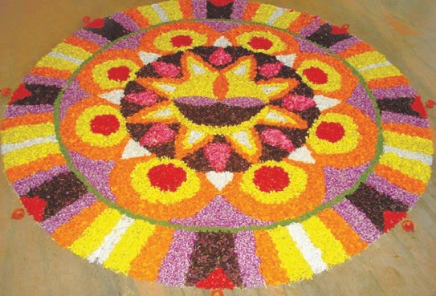

**Things to do :**

1. **Guess the meaning of the following words.**
   * pleasing * finely * magnificent
   * coarse grained * beautify * fragrant
2. **Answer the following questions.**
3. What does ‘Rangaawali’ mean ?
4. Where is Rangoli usually drawn ?
5. What is used to make Rangoli designs ?
6. What are the common Rangoli designs or motifs ?
7. What different names is ‘Rangoli’ known by in different regions ?
8. **Make a collection of Rangoli motifs and patterns. Write about each motif or pattern in your own words -**

**it could just be a label or a description or some information or a comment.**

* * *

#### Language Study

**- For the Teacher -**

The ‘Language Study’ pages contain a glossary or explanation of certain terms that are used to talk about language. These explanations should not be used as teaching items or for evaluation. While handling the passages and activities in the textbooks, the teachers may refer to these pages from time to time, and get the students to read the relevant parts from these pages, along with her. She should also show how to look up a particular word in these pages.

Some of the terms have been introduced at the end of some of the passages, with the help of questions like those given below. Those terms have been introduced in a graded manner. Once students become familiar with a term or explanation, the teacher may occasionally set similar questions on other suitable passages, for the purpose of revision.

#### Some question types :

* Find nouns / verbs from the paragraph given below.
* Read the underlined nouns / verbs and find 3-5 other nouns / verbs related to each.
* Write the singular / plural form of the noun given below.
* Use the correct noun / verb form.
* Find the adjective / adverb in the sentence.
* Use another adjective / adverb in place of the underlined one to change the meaning.
* Underline the prepositions / articles / pronouns in the paragraph given below.
* Read the sentence and say whether it shows the past, present or future tense.
* Rewrite the sentence correctly to show some other tense, e.g., past future, past present, present past, present future.
* Complete the table : Type 1 : slow - slower - slowest

Type 2 : go - went - gone

ULnaint g4uage Study **83**

**adjective :** a word that tells us something more about a **noun** or **pronoun**. Examples : a *small* box ; *fresh* mangoes ; I am *sorry* ; the *big*, *brown*, *wooden* board.

To show that something or someone has ‘more’ of a quality, we use ‘more’ before the adjective, eg., *more intelligent*, *more frightening*. If the adjective is short, (with only one or two syllables in it), we add ‘-er’ instead of using ‘more’, eg., *big- bigger*, *happy-happier.*

To show that something/someone has more of a quality than anything/ anyone else, we use ‘most’ before longer adjectives and add ‘-est’ to the shorter adjectives. Examples : *most intelligent*, *most frightening*, *biggest*, *happiest*, *softest*.

There are many adjectives which end with : -ful (useful), -less (careless), -able (washable).

**adverb :** a word that tells us something more about • a **verb** : He runs *fast*. She went *away*. The girl sang *sweetly*. *Suddenly*, the dogs started barking. She did *not* smile. • an **adjective** : The tea was *too* sweet. The lion was *very* strong. • another **adverb** : He ran *very* fast. • a **phrase** or **sentence**

: *Luckily*, he remembered the answer.

Adverbs give us information about : • place, eg., Come *here*. Come *in*. • time, eg., I saw a movie *yesterday*. *Now* I need a pen. • manner or the way something is done, eg., Read *aloud*. Stand *straight*. • degree,

eg., The water was *too* hot. • cause or reason, eg., She was tired and *therefore* unable to study.

We can use ‘more’ or ‘most’ with some of the adverbs too, eg., Stitch *more carefully*. She stitched it *most carefully*.

We add -er or -est to short adverbs like fast. Examples : Who ran *faster* ? Who ran *fastest* of all ?

Many adverbs end with -*ly*.

**alphabet :** a set of letters used for writing the words in a language. The letters have a fixed order in the alphabet. The set of letters we use for writing English is arranged from a to

z. It is known as the Roman alphabet.

**article :** The words ‘a / an’ and ‘the’ are called articles. They are used before a **noun**.

‘The’ is known as the **definite article**. It shows that the noun refers to a particular example of something, eg., I am looking for *the* blue pen.

‘A/an’ is called the **indefinite article**. It shows that the noun refers to a general example of something, eg., I want *a* pen.

Before nouns beginning with a consonant sound, we use ‘a’ ; and before nouns beginning with a vowel sound, we use ‘an’. We do this both when we speak and when we write. Examples : *a lion*, *a squirrel*, but *an ant*, *an elephant*.

The definite article is always

8844 LanguageUSntuitd4y

written as ‘the’. But when we speak, we pronounce it as ‘द’ before consonant sounds and ‘िद’ before vowel sounds, eg., ‘द’ ***l****ion* but ‘िद’ ***e****lephant*.

**conjunction :** a word that joins words, phrases or sentences. For example, *and*, *or*, *but*, *because*, *if*.

**consonant :** a **speech sound** like ‘ब्’, ‘ट्’, ‘स्’, etc., which is not a vowel. A consonant **letter** is a letter that represents a consonant sound, eg., the consonant letter ‘c’ (सी) stands for the sound ‘स्’ in ‘city’ and ‘क्’ in ‘come’.

The consonant letters we use for writing English are :

*b c d f g h j k l m n p q r s t v w x y z*

**dictionary :** a book that lists the words in a language in alphabetical order, and explains their meaning, use, pronunciation, etc.

**encyclopaedia :** a book or set of books giving facts or detailed information about many subjects. Some encyclopaedias give information about different things related with one subject.

**essay :** a short piece of writing about a particular topic.

**exclamation :** a sound, word, phrase or short sentence that shows sudden and strong emotion. For example, ‘*Oh* !’, ‘*What a surprise* !’, ‘*Too bad* !’.

**future :** It is the time after the present, the time after now. We use ‘will’ with

a verb to show that something will happen in the future, eg., ‘She *will tell* us a story *tomorrow*.’ ‘*Next year, you’ll be* in Std VI.’ • With ‘I’ and ‘we’, ‘shall’ is also used, especially in questions – *Shall* we go ? • We can also use (*be + going to + verb*) to talk about future plans, events, etc., eg., ‘I am *going to learn* music in the next vacation’.

**glossary :** a list of difficult words with their meanings, especially one given at the end of a book or passage.

**grammar :** the study or use of the rules for changing the form of words and combining them to make sentences. Each language has its own grammar.

**heading :** The title written at the beginning of a piece of writing.

**headline :** The title of a news item, printed above it in large letters ; the main points in a news bulletin on TV / radio.

**idiom :** a phrase or a sentence that has a special meaning as a whole, which may be different from the meaning of the individual words. For example, I want to *go through* the book. Here, ‘go through’ means read.

**intonation :** the rise and fall of voice that adds meaning to what is said. For example, the voice rises or goes up at the end in ‘*You need coffee* ?’ to show that it is a question.

**letter1 :** a written / printed sign that

LUannitg4uage Study 8585

stands for a speech sound. While writing English, we use **capital letters** (A, B, C, ...) and **small letters** (a, b, c, ...).

**letter2 :** a written message that is usually sent by post.

**noun :** a word that is used to name :

* a person (*Rohan*, *Reshma* as also *girl*, *doctor*, *student*) • an animal (*cow*, *hare*) • a place (*Mumbai*, *mountain*, *school*) • a thing (*table*, *house*, *milk*) • an idea or quality (*anger*, *courage*), etc.

The names given to particular persons or places are known as **proper nouns** (eg., *Anand*, *Nagpur*, *Narmada*). The rest are **common nouns** (eg., *boy*, *city*, *river*, *book*).

Some nouns refer to something that can be counted eg., *two spoons*, *three stars*. They are **countable nouns**. Some nouns refer to something that cannot be counted, eg., *light*, *water*. They are **uncountable nouns**.

A countable noun has two forms – **singular** and **plural**. When it refers to one thing, it is singular, eg., *moon*, *flower*, *man*, *cat*. When it refers to many things, it is plural, eg., *moons*, *flowers*, *men*, *cats*.

Many nouns end with -ness, -ity,

-ment, -tion.

**paragraph :** a part or section of a piece of writing. A paragraph starts on a new line and has at least one line in it. Usually, it has one main idea.

**past :** It is the time before the present time, the time that has gone by. We use past tense forms of verbs to show actions/ events in the past, eg., ‘She *took* my book yesterday.’ ‘I *was* in Std IV last year.’ ‘Long ago, there *lived* a king’.

**phrase :** a short, meaningful group of words; a meaningful part of a sentence.

**plural :** the form of a **noun**, **pronoun** or **verb** which refers to many persons or things, eg., *children*, *tigers*, *caps*, *we*, *they*. The plural of *you* is *you*.

**preposition :** a word/group of words used before a noun or pronoun to show place, time, position, etc. Examples

: *in* the park, *on* the table, *at* home, *from* Monday *to* Friday, *after* 5 pm, *in front of* the school, etc.

**present :** It is the time that is happening now. We use the present tense forms of verbs to show the actions/events that are happening now, eg., She *goes* to school. It *is raining*.

**pronoun :** a word that is used instead of a noun. The pronouns in English are *I*, *we*, *you*, *he*, *she*, *it*, *they* and their forms like *my*, *mine*, *me*.

**proverb :** a short well-known sentence or phrase that gives advice or tells you what is generally true. For example, ‘*A stitch in time saves nine*’ means ‘If one does something in time or immediately, it saves a lot of work

8866 LanguageUSntuitd4y

later’. A proverb is also known as a

#### saying.

**question :** a sentence or phrase that you use to get information or to ask for something, etc.

**rhyme1 :** a short poem or song for children.

**rhyme2 :** If two words rhyme, they end with the same sound. For example, the word ‘king’ rhymes with ‘ring’ but you cannot rhyme ‘pack’ with ‘book’.

**rhythm :** a regular repeated pattern of sounds or movement.

**sentence :** A group of words that expresses a complete idea – a statement, a question or a command, eg., *My elder brother is in college*. *Do you know this address* ? or *Be quick*.

**singular :** the form of a **noun**, **pronoun** or **verb** which refers to one person or thing, eg., *child*, *tiger*, *cup*, *I*, *it*, *he*, *she*.

**sound :** a sound is something that you hear.

**speech :** the ability to speak. • A speech

is a talk given on a particular topic.

* + The lines an actor says in a play are

also called his / her speech.

**stanza :** A stanza is a part of a poem. The lines in a stanza usually have rhyming words at the end. Separate stanzas in a poem are shown by more

space/distance between them, or by changing the arrangement of lines.

**statement :** a statement is something that you state, that is, say or write to give definite information. eg., ‘*The sky is blue*.’

**stress :** Stress is the extra force used when pronouncing or saying a **word** or **syllable**. For example, in the word ‘English’, the syllable ‘*Eng*’ is stressed. In the sentence, ‘Say it in *English*!’ the word English is stressed.

**syllable :** a part of a word. There is one vowel sound in each syllable. It may have one or more consonant sounds at the beginning or at the end. The syllables in some words are shown below : *a-go* (ago), *ac-tion* (action), *crea-ture* (creature), *jo-ker* (joker), *ex-pla-na-tion* (explanation).

Words like *no*, *cat*, *ask* have only one syllable.

**tense :** the form of a verb which shows the time at which an action happens – the **past**, the **present** or the **future**, eg., She *went*, She *goes*, She *will go*.

**title :** the name of a book, poem, story, picture, etc.

**verb :** a word or group of words that shows action – what people or things do and what happens to them (*write*, *fall*, *float*). A verb may also describe an event (It *rained*, It *became* dark,) or a state (She *was* unhappy).

LUannitg4uage Study 8787

Verbs have different forms that show **tenses**, the time of the action to which the verb refers. (**future**, **past** and **present.**)

Verbs have singular and plural forms only in the case of the present tense : *sits* (singular), *sit* (plural).

Note that we do not use singular forms with ‘I’ and ‘you’ : *I come*, *You smile*.

The verbs **be** (am/are, is/are, was/ were, being, been), **have** (has, have, having, had) and **do** (does, do, doing, did, done) can be used as main verbs in a sentence, eg., • be : I *am* twelve years old. They *were* ready. • have : I *have* a brother. The dinosaur *had* a long tail. • do : *Do* your best.

These verbs are also used with the main verbs in a sentence to show certain things. Then, they are called **auxiliary** or helping verbs.

* ‘Be + main verb’ shows that the action is not complete ; it goes on, eg., I *am* running. It *is* raining. They *were* playing.
* ‘Have + main verb’ shows that the action about which we are talking now, is/was complete, eg., I *have* done my homework. She *had* read the book.
* ‘Do’ is used with the main verb

to form -

(a) questions : *Do* you *know* the answer ? *Did* you *see* the bird ? What *do* you *want* ? What *did* the queen *tell* them ? (b) negative sentences : We

* ‘Be’ and ‘have’ auxiliaries too are used to form questions and negatives. ‘Do’ is not needed when these are used, eg., Questions : *Are* you *writing* a story ? *Have* you *written* this ? Why *have* you *come* back ? Negatives : I *was not feeling* well. She *had not seen* the book.

There are other verbs like *can*, *could*, *may*, *might*, *will*, *would*, *shall, should*, *must*, *ought to*, *used to*, etc. which show whether something is possible, allowed, necessary, etc. These are known as **modal** verbs. They, too, are used as auxiliaries with the main verbs. Examples : I *can* swim. You *may* come in. You *should* not work too hard. *Must* you go ?

Some verbs end with -ize (dramatize) or -ify (classify).

**vowel :** a **speech sound** you make without closing any part of your mouth or throat. For example, ‘ॲ’, ‘ई’. A vowel *letter* is a letter of the alphabet that stands for a vowel sound. The vowel letters are : *a*, *e*, *i*, *o*, *u*. The letter ‘y’ too, sometimes stands for a vowel. Note that one letter may stand for different sounds in different words. For example, the same vowel letter ‘a’ stands for different vowel sounds in the words **a**ll, **a**te, **a**nt, **a**rm, etc.

**word :** a group of sounds or letters that has meaning. A word is a unit of language. A word is written by leaving spaces on both the sides.

*did not go* back. * * *

8888

LanguageUSntuitd4y

